Data Analytics Graduate Capstone – WGU C772

TCM2 – TCM2 TASK 2: DATA ANALYTICS REPORT

Nadeem Ahmed

May 2022

**A. Research Question:** Summarize the original real-data research question you identified in task 1. Your summary should include justification for the research question you identified in task 1, a description of the context in which the research question exists, and a discussion of your hypothesis.

The research question for this project is: **What factors affected vehicles rolling over during an accident in 2020?**

This research question can help drivers in understanding factors that may avoid an accident that leads to their vehicle rolling over. Driver’s will be able to utilize this analysis to make responsible and effective decisions. This data analysis could also help legislators and car manufacturers in determining how to prevent rollovers in the future. The context in which the research question exists is in everyday life when commuters are driving their vehicles. This could help all drivers in making better assessments from the point of purchasing a vehicle to driving at high speeds on rough terrain.

I believe that speed and terrain statistically significantly affect rollover. These two factors are most likely, in my opinion, to affect the chances of a vehicle rolling over during an accident. Vehicles traveling at high speeds on terrain that may have varying traction could cause a vehicle to rollover under certain conditions.

The objective in this analysis is to determine a minimum set of predictor variables that can help in predicting vehicle rollovers using logistic regression.

Here are the assumptions that must be met for a logistic regression model to be valid.

* There is little or no multicollinearity (high correlation) among predictor variables
* Binary regression requires the dependent variable to be binary.
* Variability needs to be reduced to only the meaningful variables.
* Predicts the probability of an outcome instead of the outcome itself.
* Large sample size is necessary.
* Binomial distribution rather than Gaussian distribution (rollover_true vs rollover_false).
* Logarithm of odds of achieving 1. Independent variables are linearly related to the logit (log odds).

This analysis will be able to determine which factors affect rollover.

**B. Method Justification:** Report on your data-collection process by describing the relevant data you collected, discussing any advantages and disadvantages of the data-gathering methodology you used, and discussing how you overcame any challenges you encountered during the process of collecting your data.

The data collection process was simple. I gathered this dataset from the National Highway Traffic Safety Administration (NHTSA) website at [www.nhtsa.gov](http://www.nhtsa.gov). They have a dedicated portal for downloading their publicly available free datasets of accidents and other reported data. The specific dataset I was interested in was collected by the Fatality Analysis Reporting System (FARS). Among this .zip file (‘FARS2020NationalCSV.zip’), there were csv titled ‘PBType.csv’, ‘person.csv’, ‘race.csv’, ‘weather.csv’. The file that would lead me to answer the research question is titled ‘vehicle.csv’.

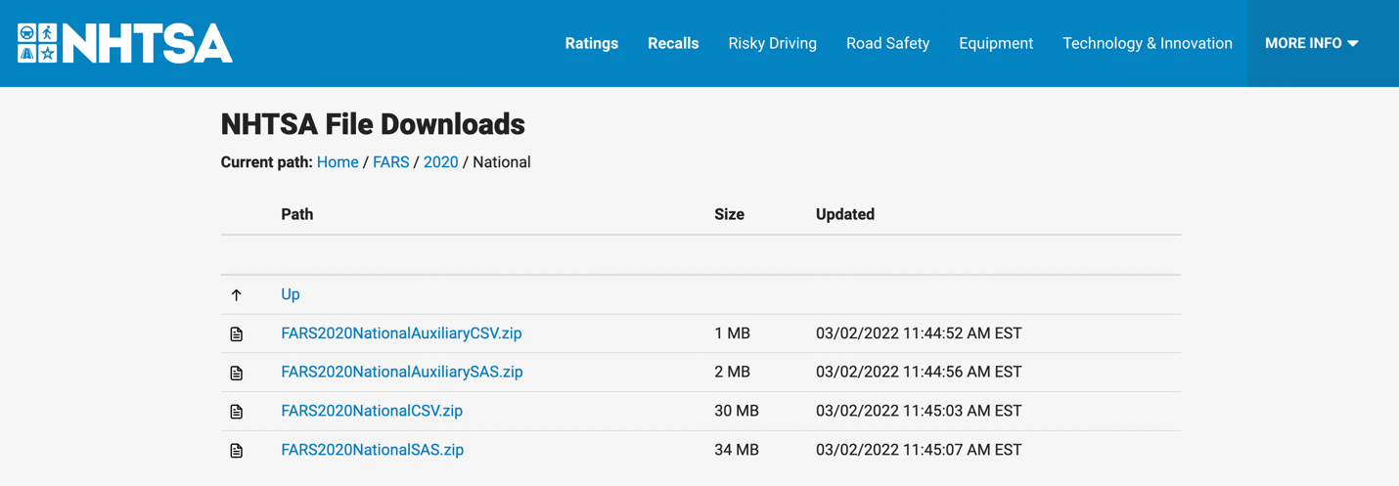

This csv file (‘vehicle.csv’) has 201 columns ranging from State Case number (ST_CASE) to the VIN to the surface condition of the ground where the accident took place (VSURCONDNAME; wet, dry, ice/frost, etc.). Among these columns there is one titles ROLLOVER. The outputs of this field vary, including:

* No Rollover
* Rollover, Tripped by Object/Vehicle
* Rollover, Unknown Type
* Rollover, Untripped.

This dataset includes which accidents lead to a rollover vehicle, the make/model of the vehicle, the speed of the vehicle, the terrain the vehicle was driving on, how many lanes were present on the street the accident occurred, the time of day the accident occurred, as well other pertinent information. There are many factors that could affect rollover.

**Part C. Data Preparation:** Describe your data-extraction and -preparation process and provide screenshots to illustrate each step. Explain the tools and techniques you used for data extraction and data preparation, including how these tools and techniques were used on the data. Justify why you used these particular tools and techniques, including any advantages or disadvantages of these when used with your data-extraction and -preparation methods.

I began by importing the necessary packages that would be vital in the preparation, manipulation, analysis, and visualization. This includes *pandas*, *seaborn*, *matplotlib*, *numpy*, and *sklearn*. Then, I’ll read the data into Python using the *pandas* package ‘read_csv’ command.

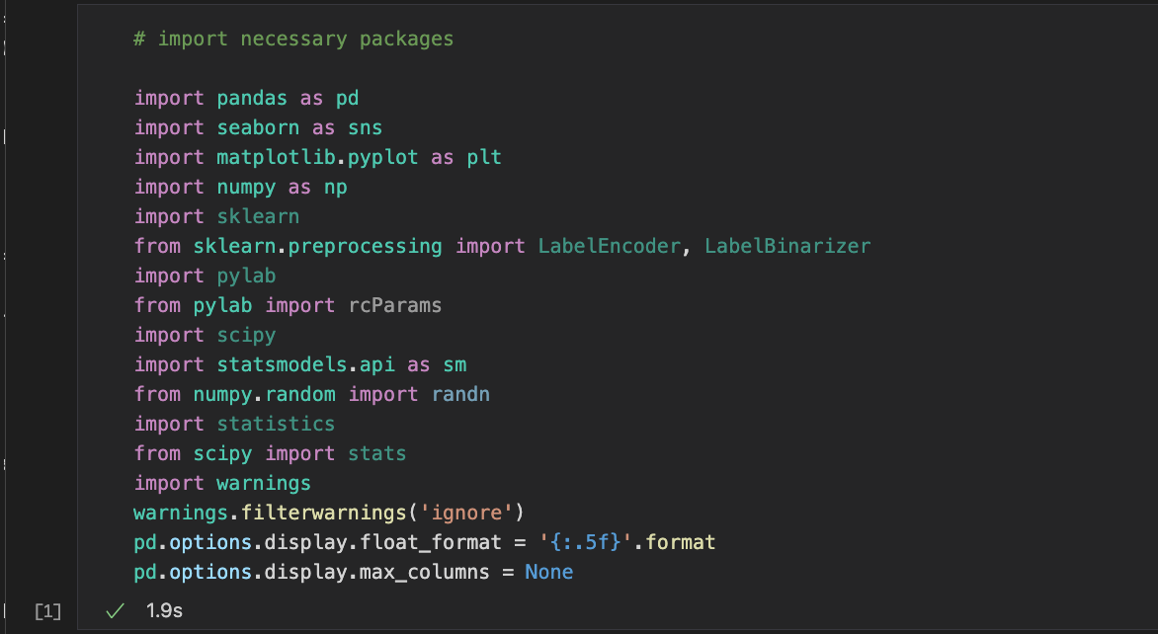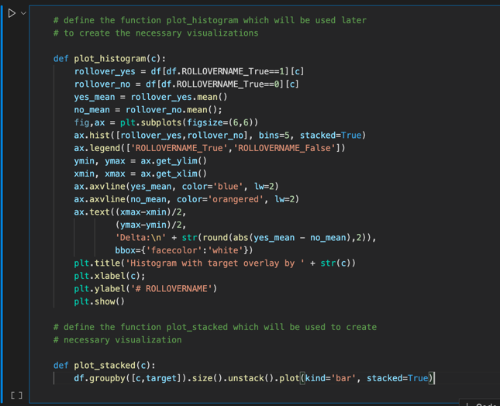

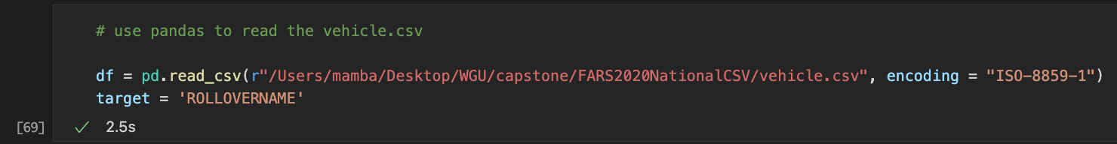

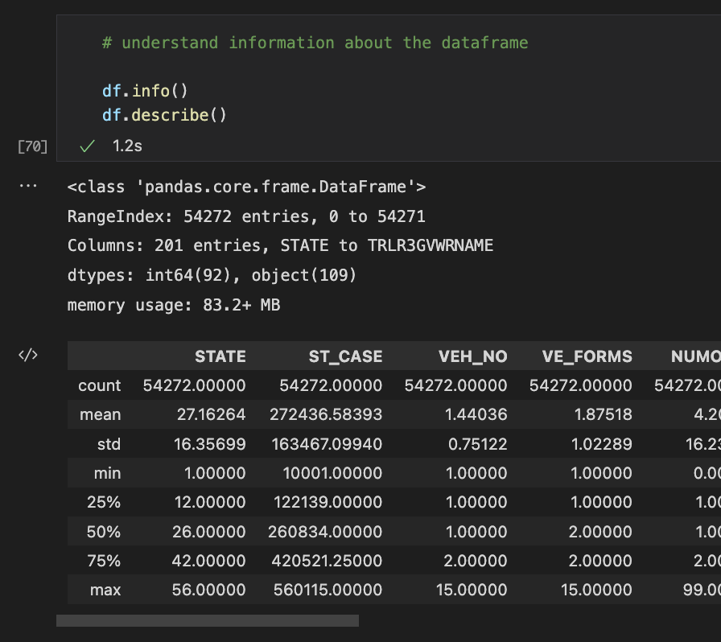Next, we use the ‘info()’ and ‘describe()’ functions to understand the dataset a bit more. We see that there are 54,272 entries and 201 columns.

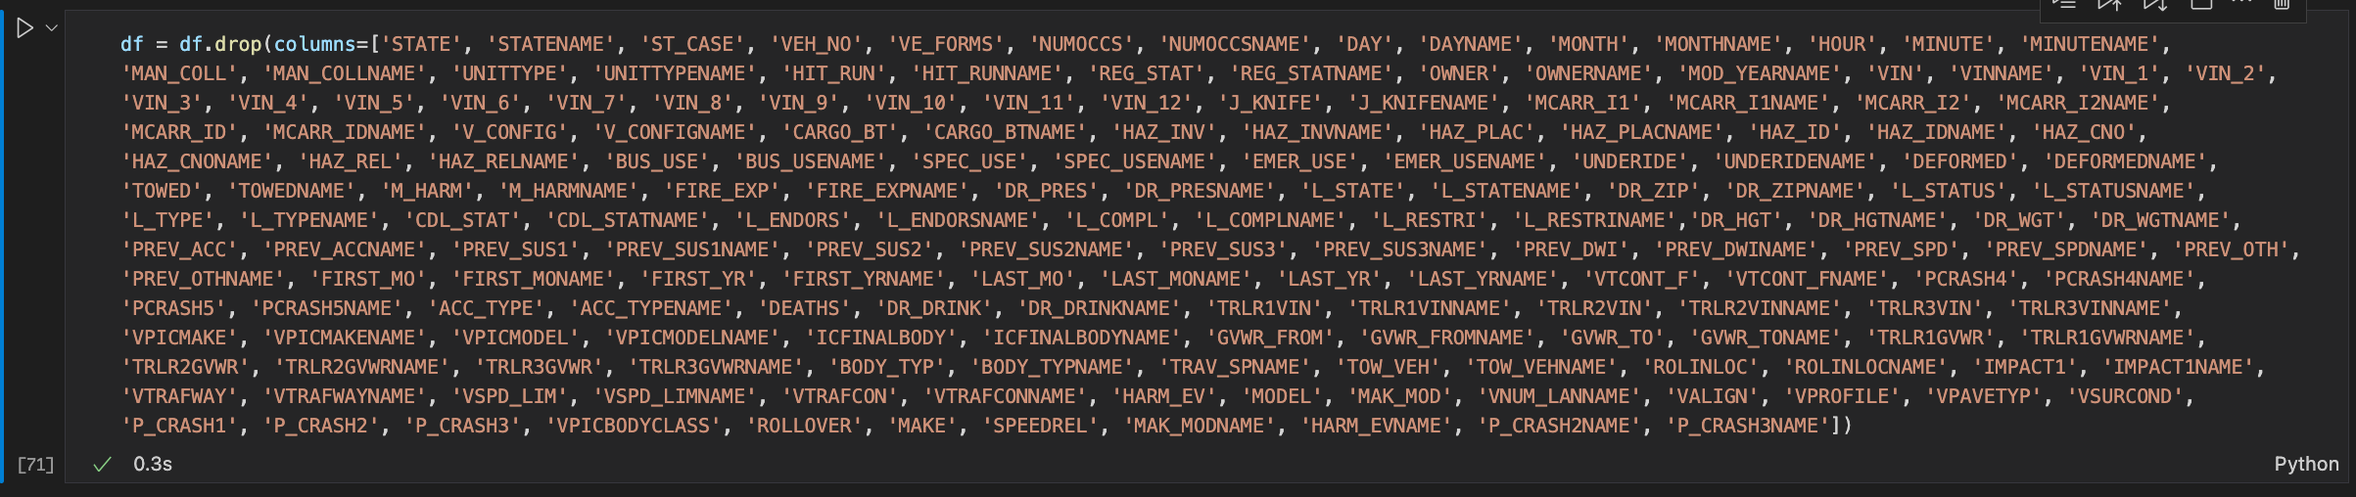We then jump right into the columns to see which columns will be viable assets to the analysis and which will not. I created a list of columns that will be removed from the dataframe.

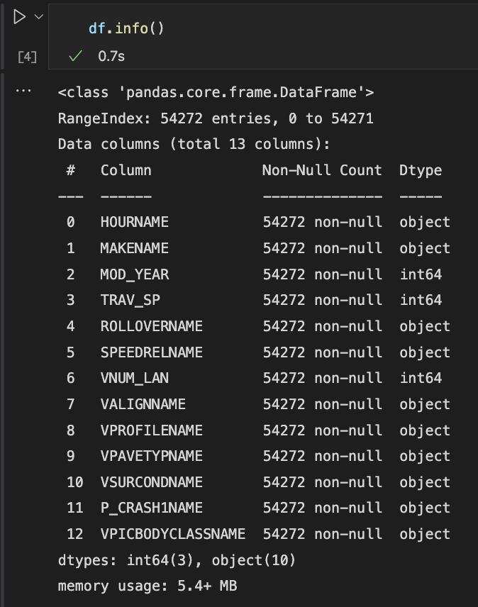After we have gotten rid of most of the columns that may not be of use in predicting ROLLOVER, we are left with 13 columns. That may seem like a huge jump from 201 initial columns but most of the columns are unnecessary in the analysis or repetitive like ‘DAY’, ‘DAYNAME’, ‘PCRASH3’, etc. We also decide to keep the categorical variables instead of their numerical counterparts. For example, I dropped ROLLOVER which contains ID numbers to identify the type of ROLLOVER situation. This is technically a numeric datatype, but the actual data is categorical. So, we drop ROLLOVER and keep ROLLOVERNAME which contains the actual categorical data as an object datatype (No Rollover, Rollover, etc.).

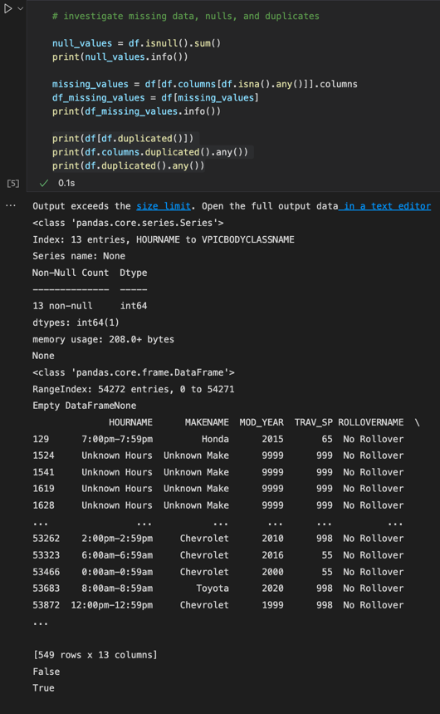Identify nulls, missing values, and duplicates is the next part of the data preparation stage. The analysis shows that there were no null values, no missing values, but there were duplicates in the dataset.

We move on to exploring the target variable, ROLLOVER. This is a categorical variable. Our first step is to get the value counts of this variable. There are

* 45,998 No Rollover accidents,
* 6,376 Rollover, Tripped by Object/Vehicle
* 978 Rollover, Unknown Type and
* 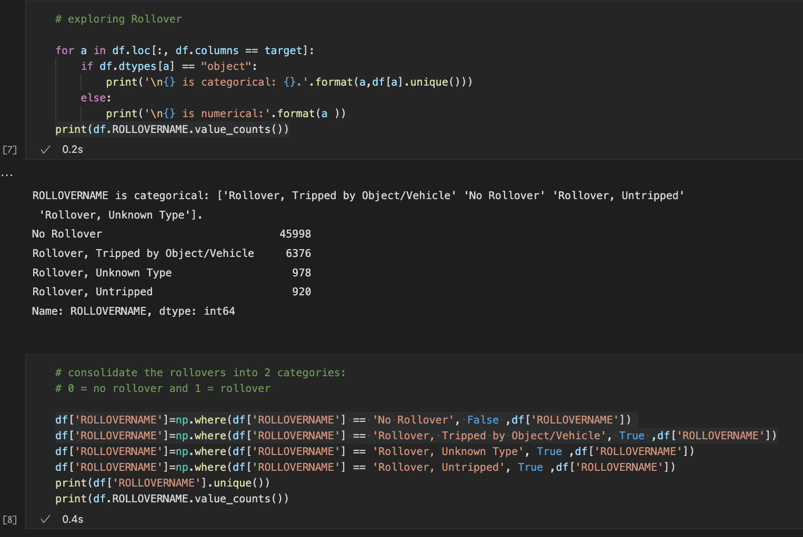920 Rollover, Untripped

We don’t really care the type of ROLLOVER incident; we just want to know whether there was a ROLLOVER or not. So, we consolidate all the ROLLOVER values to True, and No Rollover to False. Now this field is a Boolean datatype.

The next step is to dive deeper into each of the predictor variables and see what can be consolidated there to make the analysis clean and less cluttered.

HOURNAME:

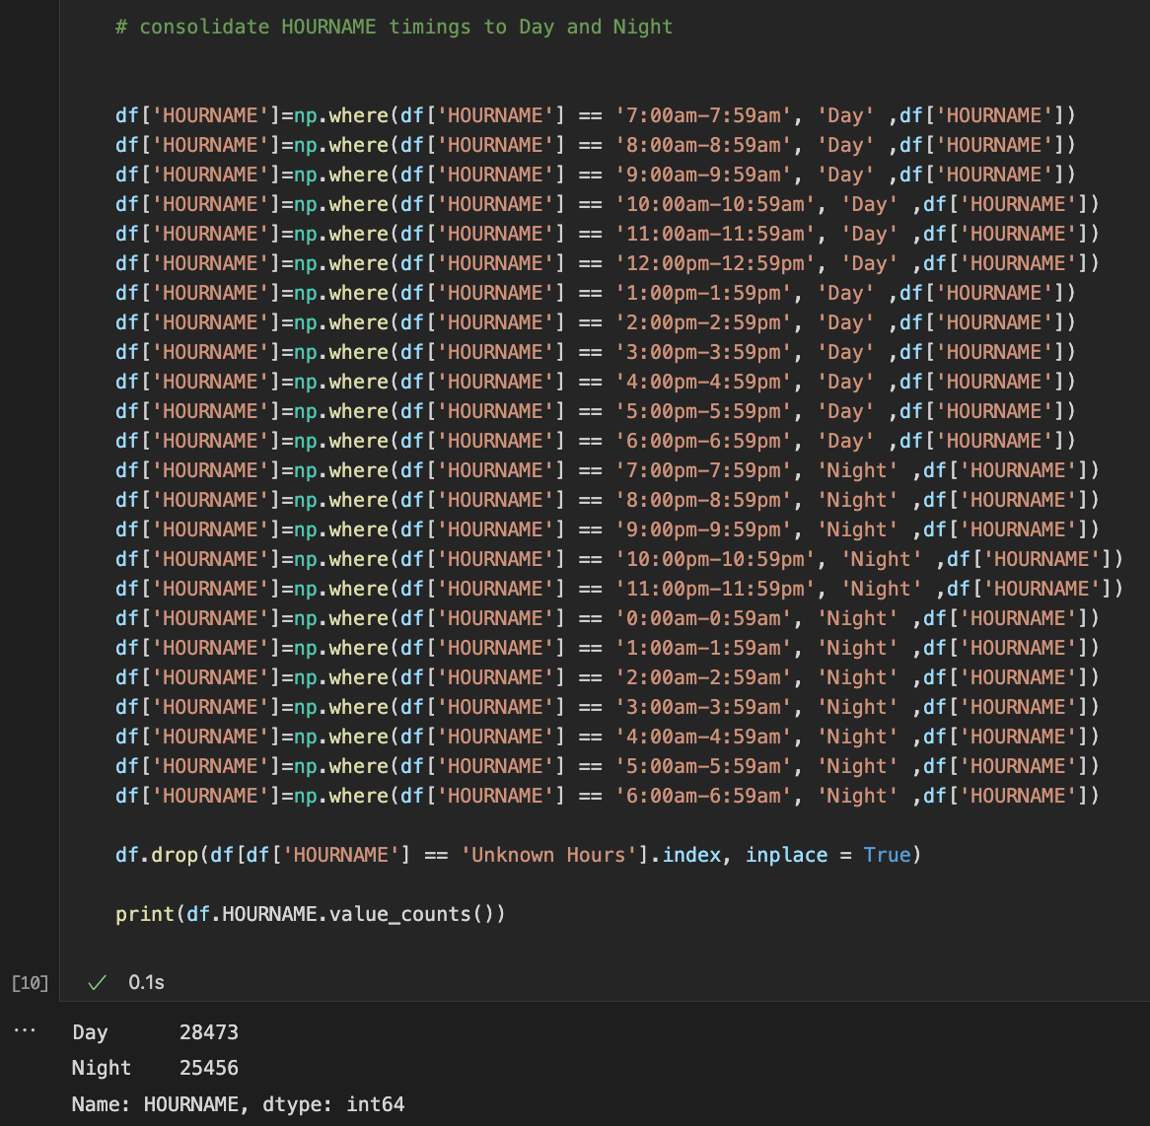We explore HOURNAME which is a categorical predictor variable to see that this is an extensive list of time ranges. This can easily be converted to a simple Boolean datatype but to keep things a little understandable we’ll change them to ‘DAY’ and ‘NIGHT’.

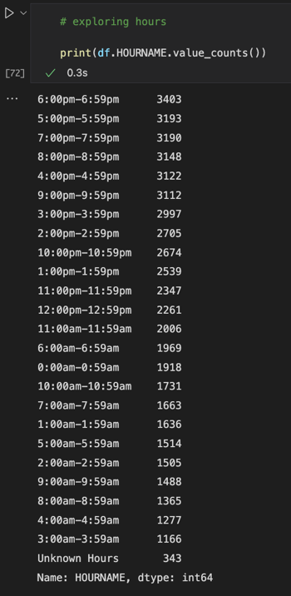

After we change the time ranges to respective Day and Night values, we see 28,473 Day values and 25,456 Night values. Almost evenly distributed. There were 343 Unknown Hours values that we dropped from the dataframe. This is extraneous data that would provide erroneous results if kept in the analysis. We started with 54,272 rows and now after this drop from the dataframe, we are left with **53,929** rows.

MAKENAME:

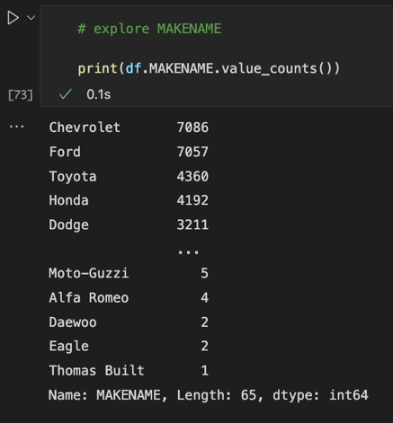We explore MAKENAME which is a categorical predictor variable to understand what are the values that make up this variable. A quick value.count() function shows us that there are about 65 different vehicle makes but the majority are Chevrolet, Ford, Toyota, Honda, Dodge, and Nissan. This led me to make the decision to analyze American and Japanese makes further. All the other makes would be placed into the ‘Other’ category.

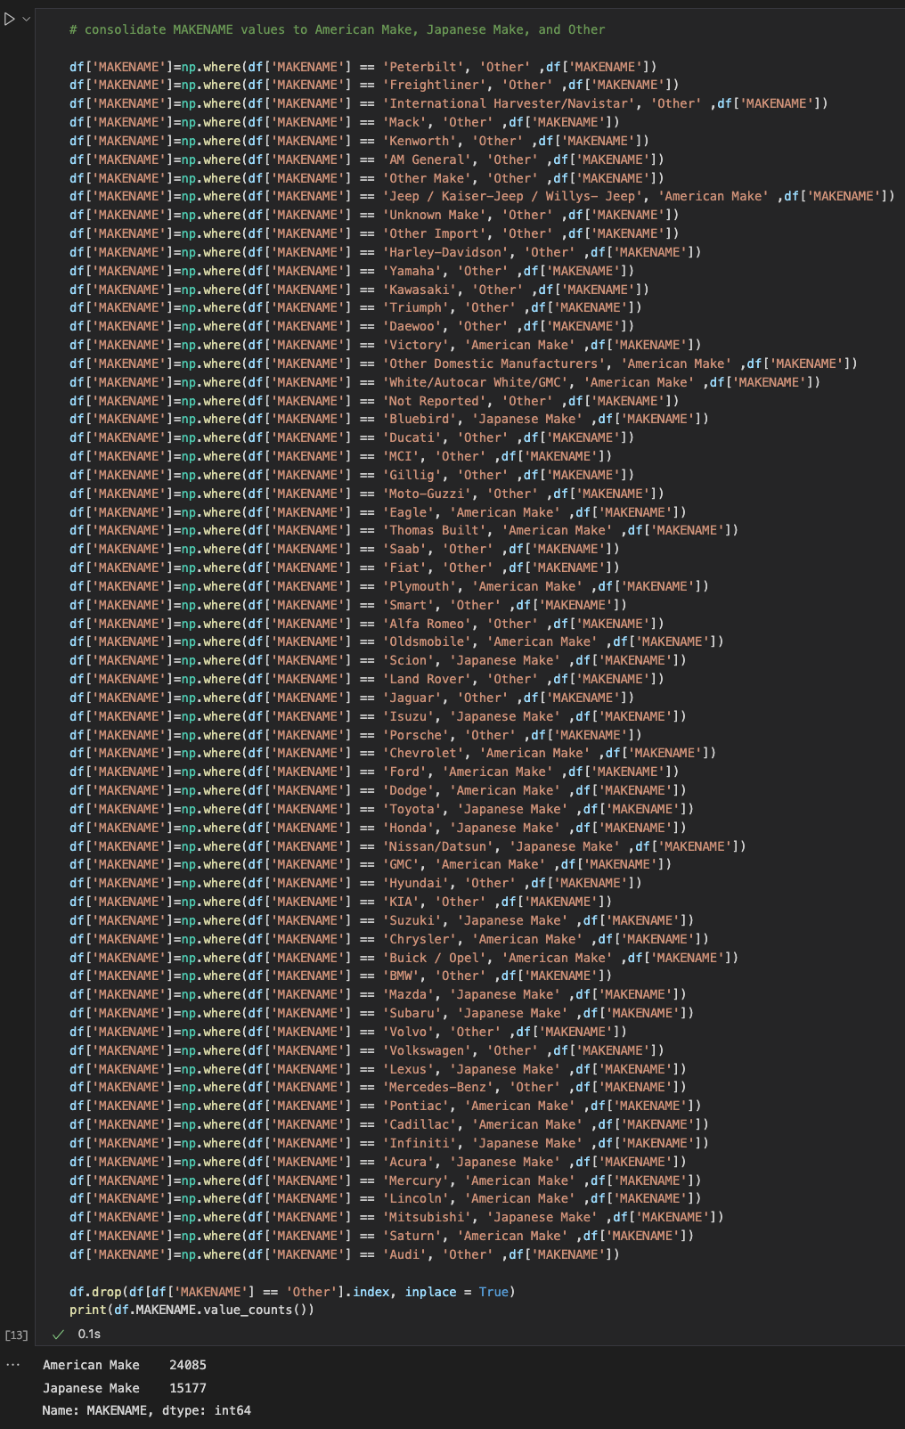

After consolidating all the MAKENAMES into proper categories of either ‘American Make’, ‘Japanese Make’, and ‘Other’, we are left with 24,085 American made vehicles and 15,177 Japanese made vehicles. All other trucks, motorcycles, RVs, buses, etc. were put into the ‘Other’ category. We drop all the ‘Other’ values from the dataframe. We left off with 53,929 rows and now after this drop from the dataframe, we are left with **39,262** rows. We removed 14,667 rows.

MOD_YEAR:

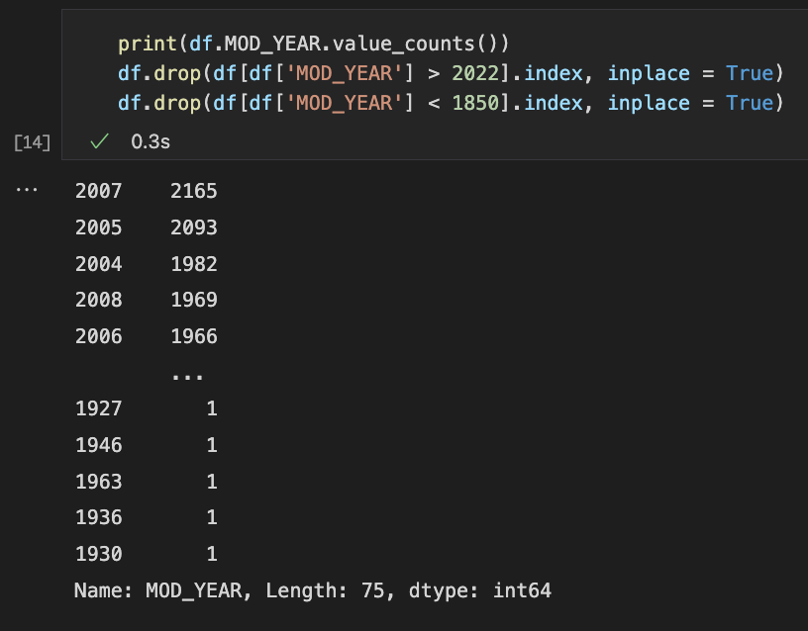MOD_YEAR is a numerical predictor variable for the year the model of the vehicle was released. We explore MOD_YEAR to see counts for years. We notice that years range from 1930 to 2022, however there are a few values of ‘Not Reported’ and ‘Unknown’. For that reason, we need to drop those extraneous values. We left off with 39,262 rows and now after this drop from the dataframe, we are left with **39,166**. We removed 96 rows.

TRAV_SP:

TRAV_SP is a numerical predictor variable for the speed that the vehicle was traveling at when they got in the accident. The range varies from 0 to 999. The values 997, 998, and 999 designate ‘Greater than 151mph’, ‘Not Reported’, and ‘Reported as Unknown’, respectively. At first, my plan was to remove these values as they do not assist in our analysis. However, when I did that, we would end up removing about 24,000 rows of unreported or unknown value data. Instead, we will replace the 997 as 152 mph, 998 as 55 mph, and 999 as 55 mph. We choose 55 mph because that is the median. This allows us to work with more data instead of removing more than half of our dataset.

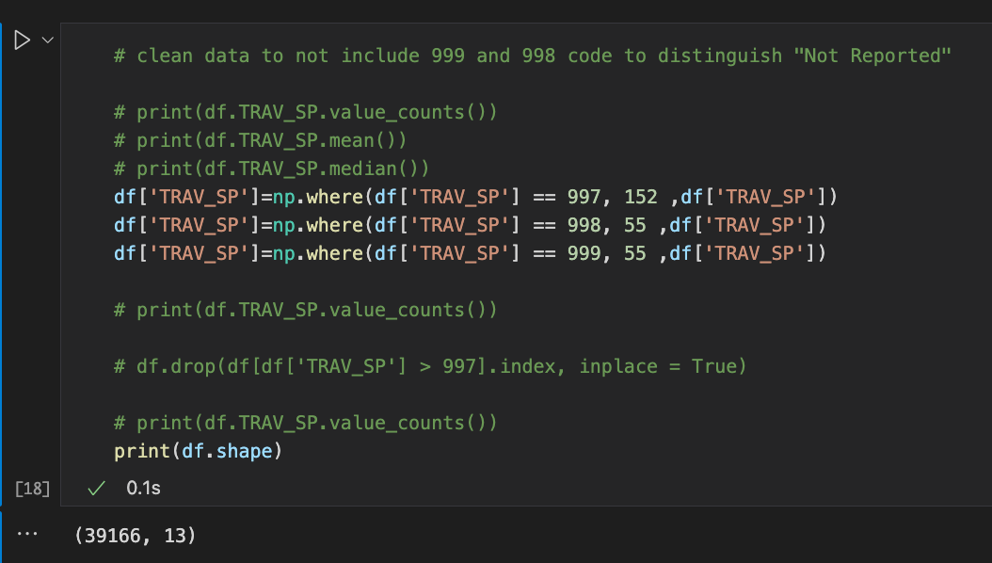

SPEEDRELNAME:

SPEEDRELNAME is a categorical predictor variable which designates whether the driver was driving over the speed limit or not. The range for this variable includes a few ‘No…’ and a few ‘Yes…’ values. We consolidate those to simple ‘True and ‘False’ Boolean values.

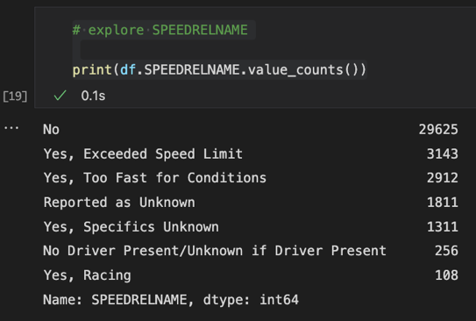

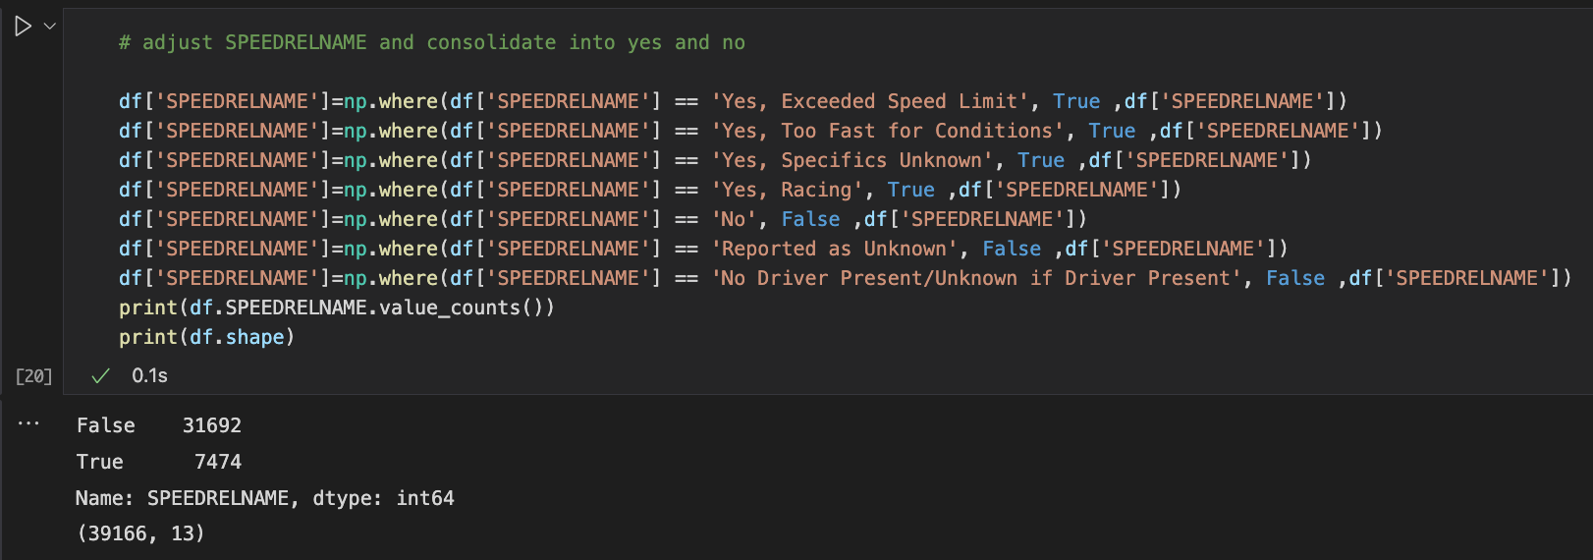Once we’ve consolidated everything, we have 31,692 False rows and 7,474 True rows.

VALIGNNAME:

VALIGNNAME is a categorical predictor variable which designates the alignment of the roadway. The values range from Straight to some variation of Curved. We consolidate all the values that can be consolidated and remove the ‘Other’ values which contain ‘Not Reported’ and ‘Unknown’. We are left with 38,268 rows.

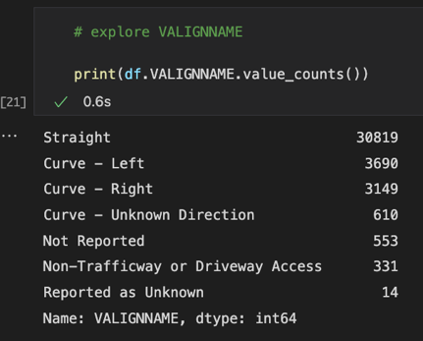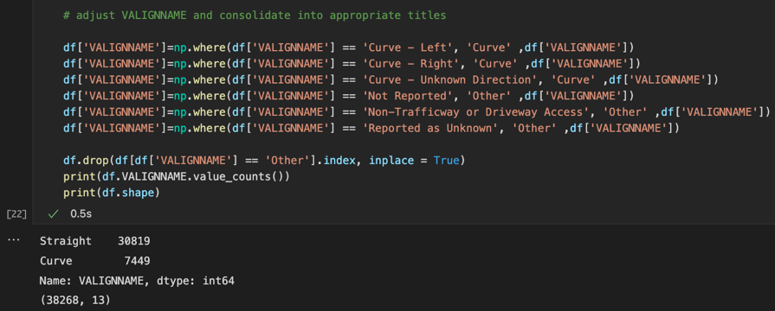

VPROFILENAME:

VPROFILENAME is a categorical predictor variable which designates the slope of the roadway where the accident took place. The values range from ‘Level’, ‘Uphill’, ‘Downhill’, etc. We explore the value counts and then consolidate where we can.

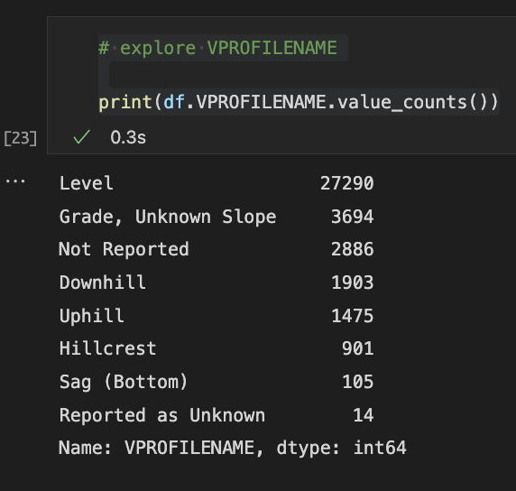

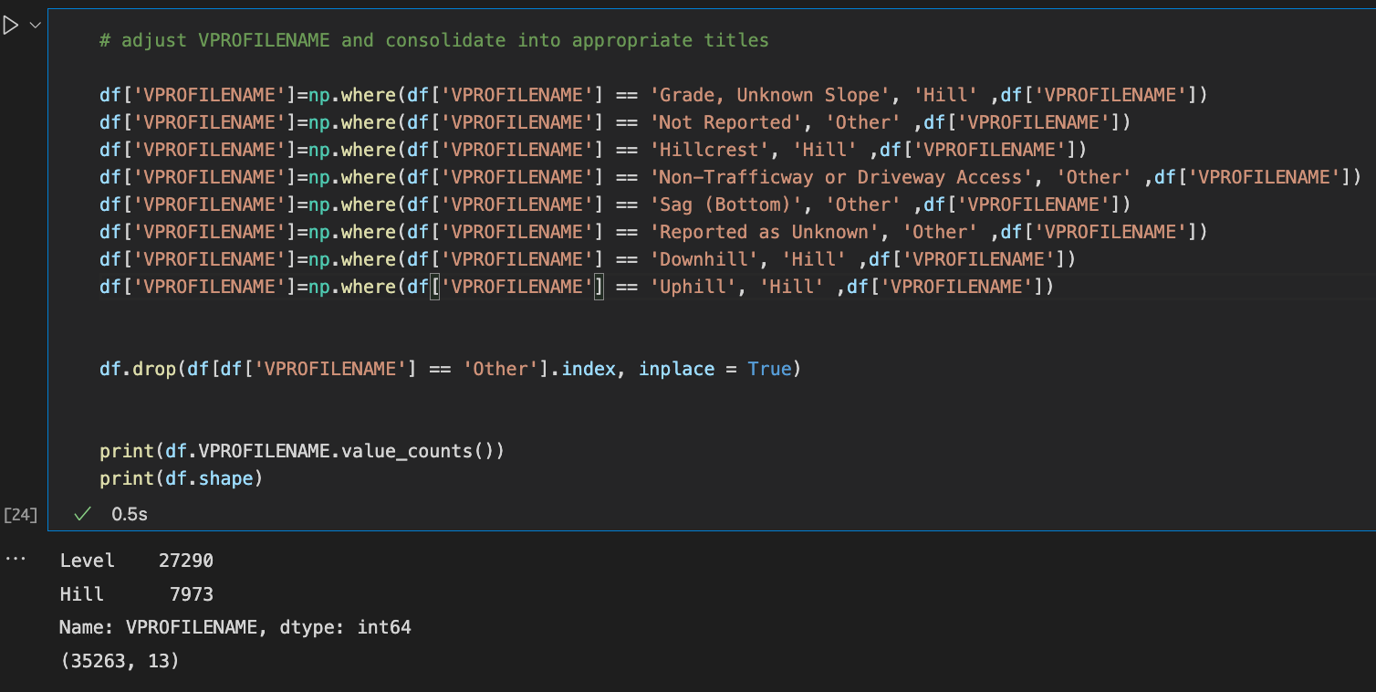

After consolidation, we designated the values into two categories, ‘Level’ and ‘Hill’. There are 27,290 ‘Level’ values and 7,973 ‘Hill’ values. The values that were put into the ‘Other’ category were dropped. After the drop, we are left with 35,263 rows in the dataframe.

VPAVETYPNAME:

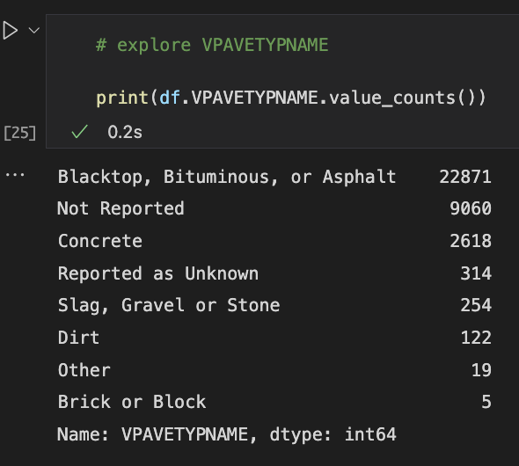VPAVETYPNAME is a categorical predictor variable that designates the material of the roadway where the accident occurred. The values range from ‘Blacktop, Bituminous, or Asphalt’ to ‘Dirt’. We really want to see the Blacktop vs Dirt and so we create the categories as such and remove the ‘Other’ categories that don’t meet that criteria.

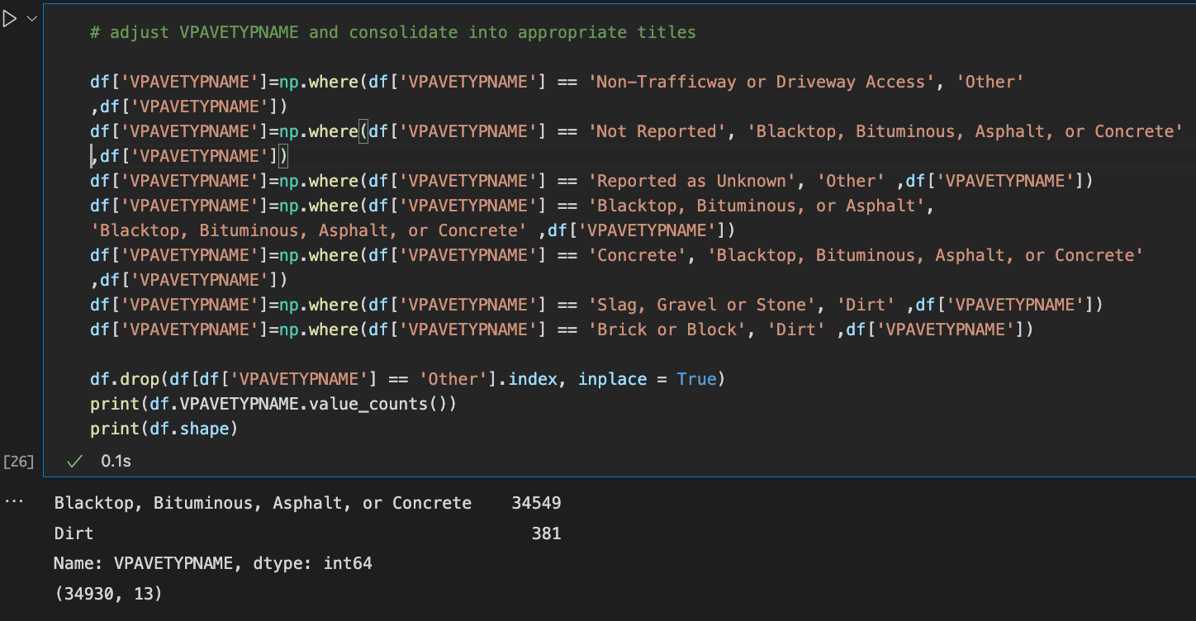We notice that there are 9,060 ‘Not Reported’ values. Ideally, we would remove these from the dataset by placing them in the ‘Other’ category as we have been doing for other variable cleanup measures. However, almost ten thousand rows would be removed from the dataset then. I decided to change the ‘Not Reported’ values to ‘Blacktop, Bituminous, or Asphalt’ category as that is the common and culminating of the options.

After the cleanup we see that there are 34,549 ‘Blacktop, Bituminous, or Asphalt’ rows and 381 ‘Dirt’ rows. We got rid of 333 rows in this iteration.

VSURCONDNAME:

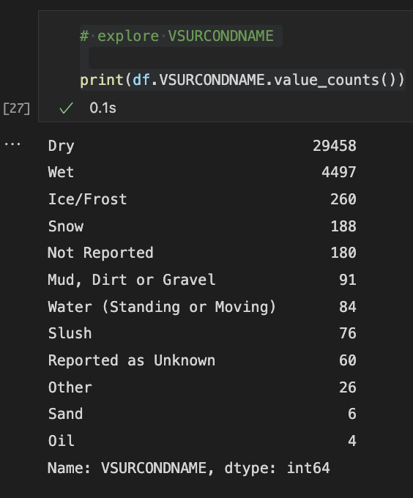VSURCONDNAME is a categorical predictor variable that designates the condition of the roadway where the accident took place. The conditions vary from Dry, Wet, to Ice/Frost. We explore this variable to understand the value counts.

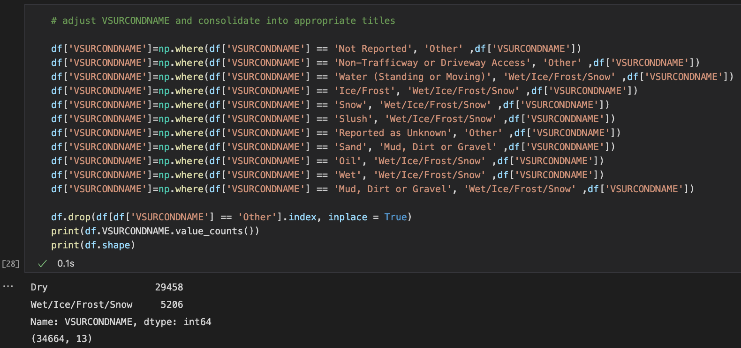

We consolidated the values into two categories, dry and wet. What we couldn’t categorize as dry or wet, we moved to the ‘Other’ category to be dropped later. There are 29,458 Dry incidents and 5,206 Wet incidents. After dropping 266 ‘Other’ values, we are left 34,664 rows.

P_CRASH1NAME:

P_CRASH1NAME is a categorical predictor variable that designates the motion the car was doing when it first got into the crash. The values of this variable vary from ‘Going Straight’ all the way to ‘Making a U-Turn’. We explore this further using value.count().

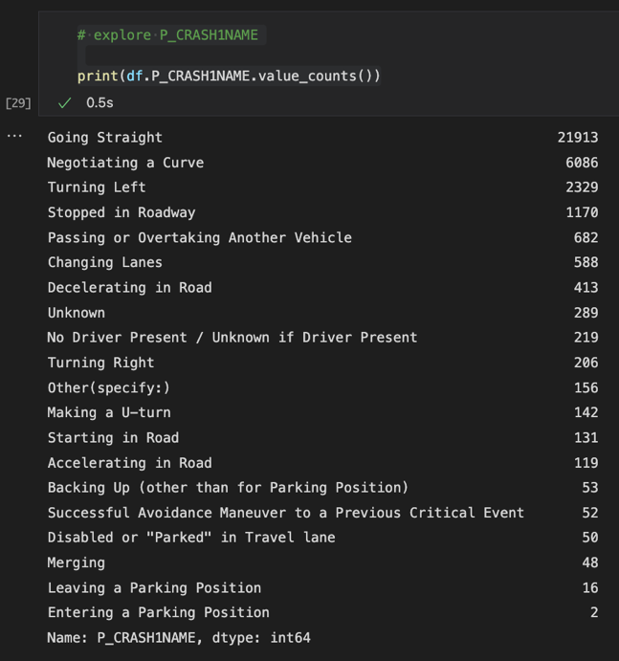

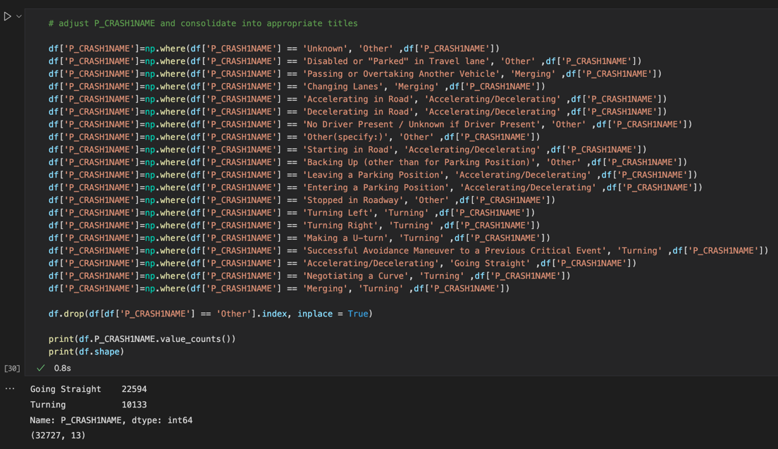

We designate 2 categories to accommodate all the values, ‘Going Straight’ and ‘Turning’. There are 22,594 ‘Going Straight’ values and 10,133 ‘Turning’ values. We dropped 1,937 leaving a total of 32,737 rows in the dataframe.

VPICBODYCLASSNAME:

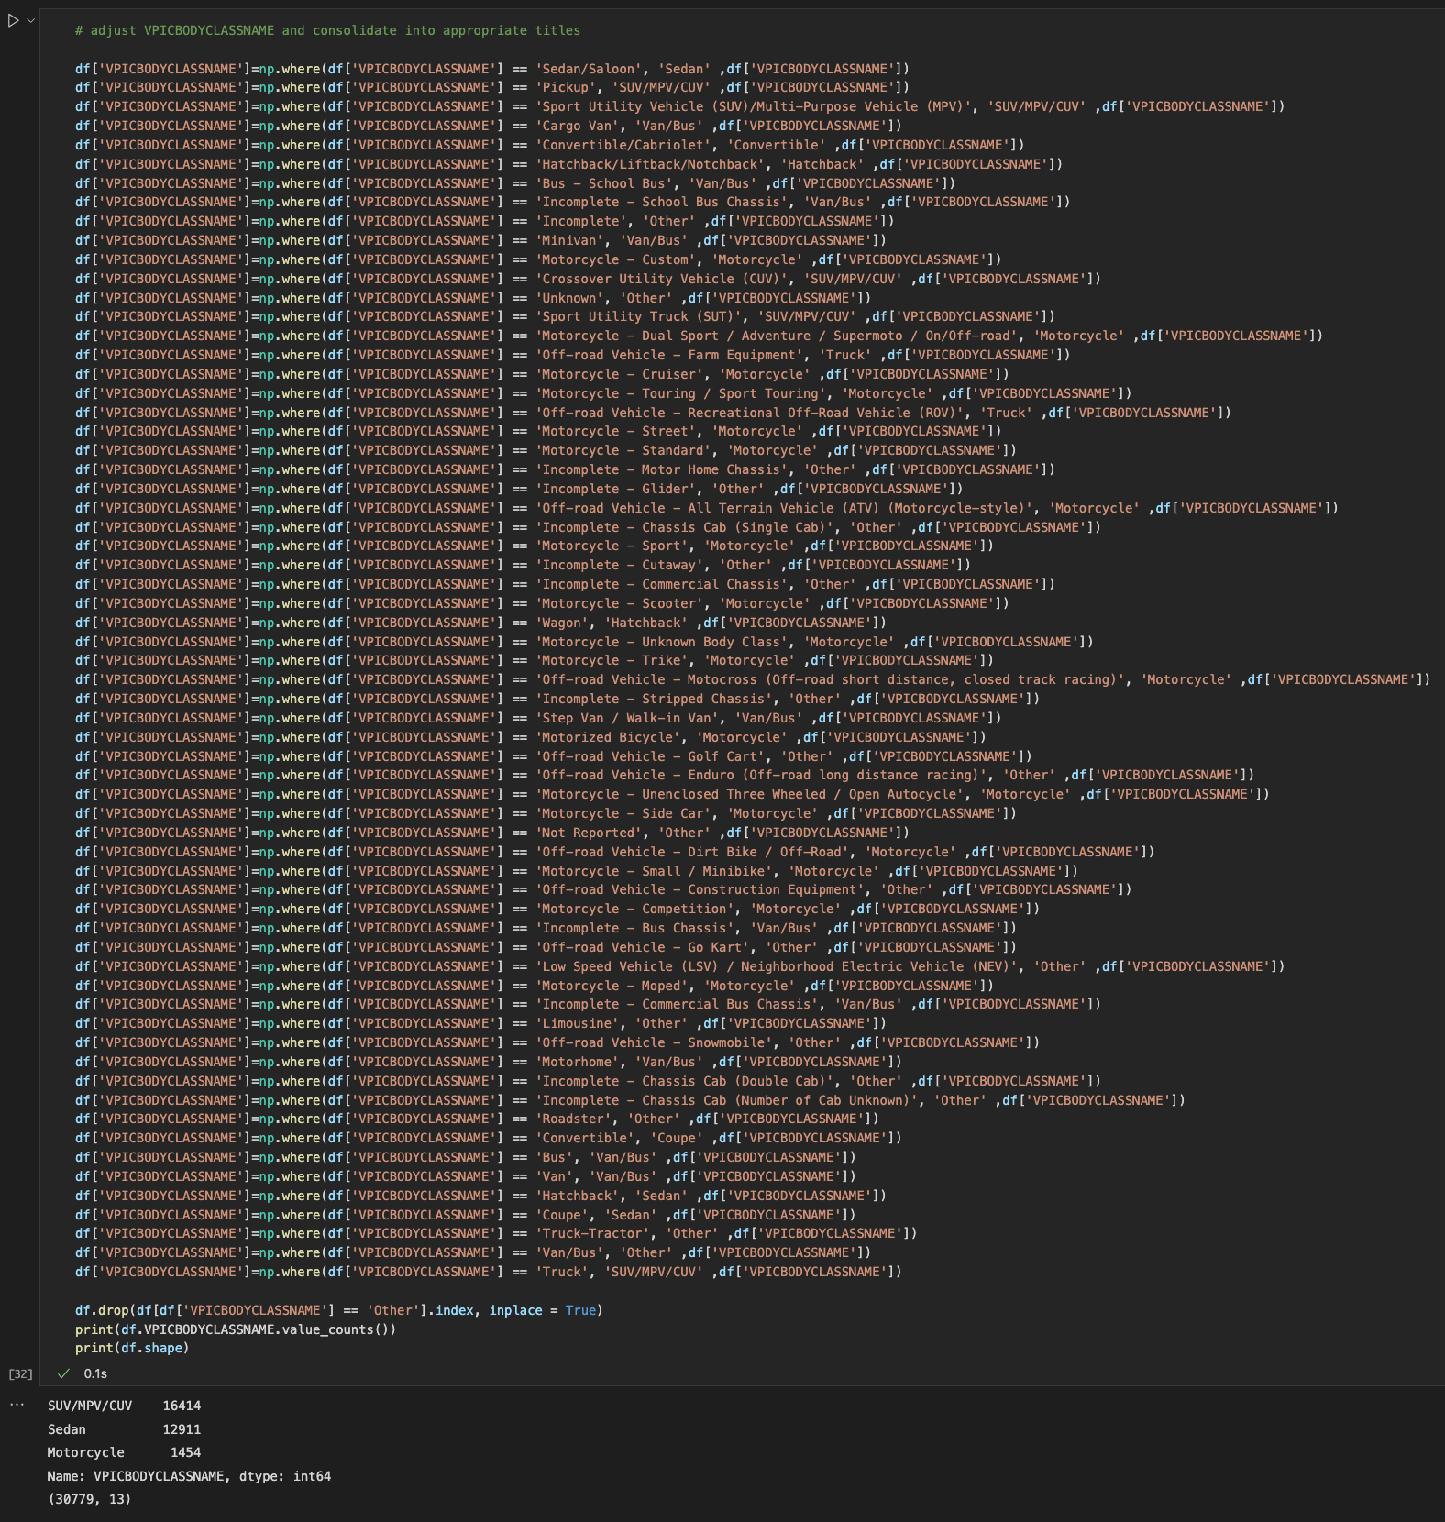VPICBODYCLASSNAME is a categorical predictor variable that designates body class type of the vehicle. The variable values vary from ‘Sedan’ to ‘Motorcycle’ to ‘Van’. We need to consolidate these into categories that can be used properly for the analysis. We examine this variable.

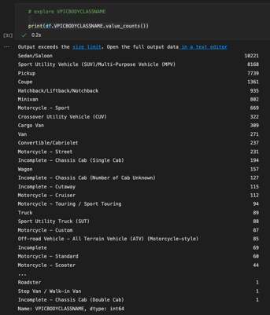

After this consolidation effort, we designated 4 different categories: 16,414 rows in ‘SUV/MPV/CUV’, 12,911 rows in ‘Sedan’, 1,454 rows in ‘Motorcycle’, and 1,948 rows in ‘Other’. We dropped all the rows in the ‘Other’ category leaving us with a total of 30,779 rows in the dataframe. This is the final count after cleaning up all the variables and dropping all the irrelevant rows for this analysis.

The cleanup and consolidation effort are now complete, and this is the resultant analysis which shows the variables, their outputs, and their type:

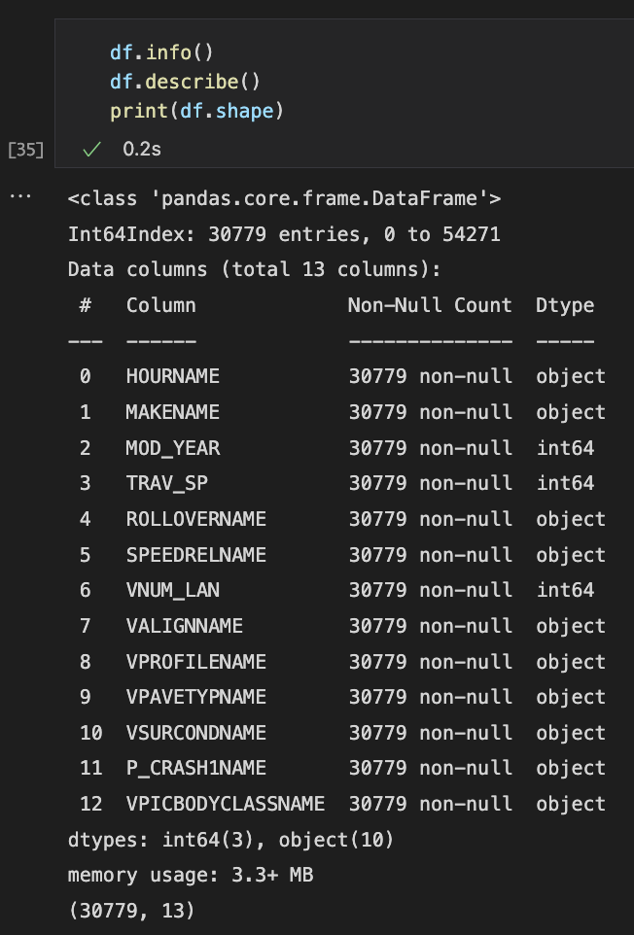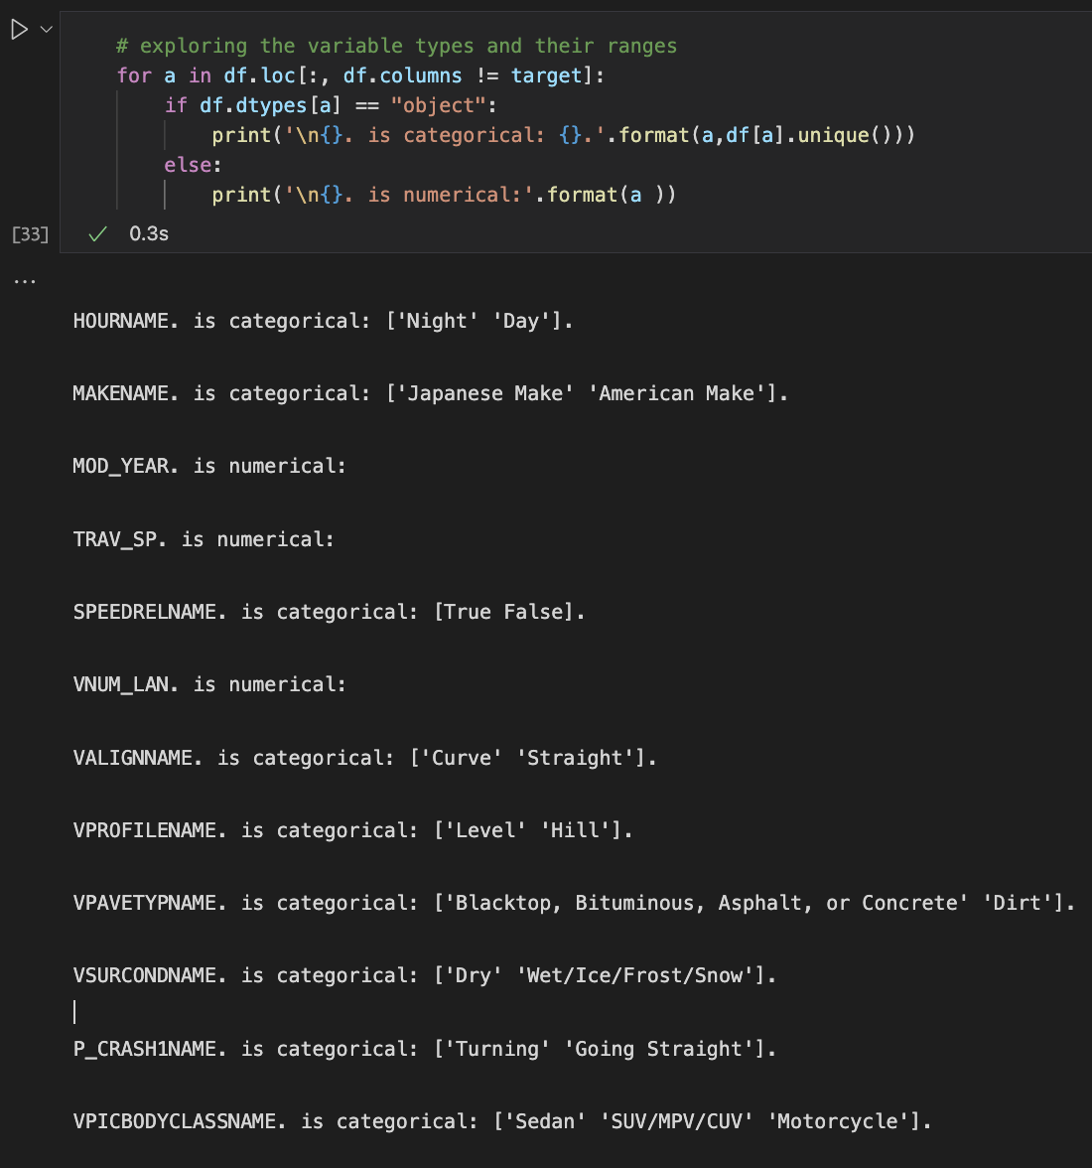

JUSTIFICATION OF TOOLS/TECHNIQUES:

This analysis is done using Python, Jupyter Notebook, and VSCode. The benefit of Python is the abundance of statistical and modeling packages available including pandas, scikit, seaborn, numpy, etc. They are easy to configure, and Python is a simple, yet multi-faceted programming language which can accomplish much with a few lines of code. It is fast in comparison to R, as well. Throughout the analysis, we will be conducting data cleanup, data wrangling, and data analysis. Python helps achieve these techniques and Jupyter Notebook will provide a clean and readable output which will exemplify the analysis. Python has a package called ‘sklearn’ which will assist heavily in the logistic regression analysis.

Logistic regression is an appropriate technique because the dependent variable we are investigating is binomial; ROLLOVER can either be a yes or no, therefore it is binary. The purpose of the research question is understood: which factors affected rollover during accidents in 2020? This will be done by removing predictor variables in a logistic regression analysis and seeing the correlation that has on the degree of accuracy, fit, and relationship to the target variable, ROLLOVER.

**Part D. Analysis:** Report on your data-analysis process by describing the analysis technique(s) you used to appropriately analyze the data and by justifying the tools used in your data analysis. Include the calculations you performed and their outputs. Justify how you selected the analysis technique(s) you used, including any advantages or disadvantages of these technique(s).

The first part of the analysis will show univariate and bivariate analysis along with representative graphics. The second part of the analysis will be a logistic regression analysis which will produce a reduced equation that will be able to assist in predicting rollovers.

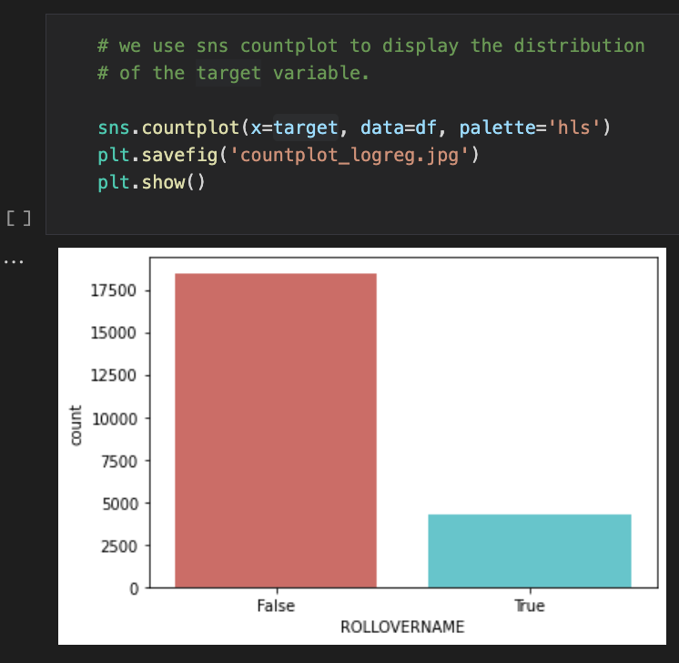

We begin by doing a bivariate analysis of the counts of ROLLOVERs in a countplot. We notice that there are about 5,000 rollover accidents reported in this 2020 dataset.

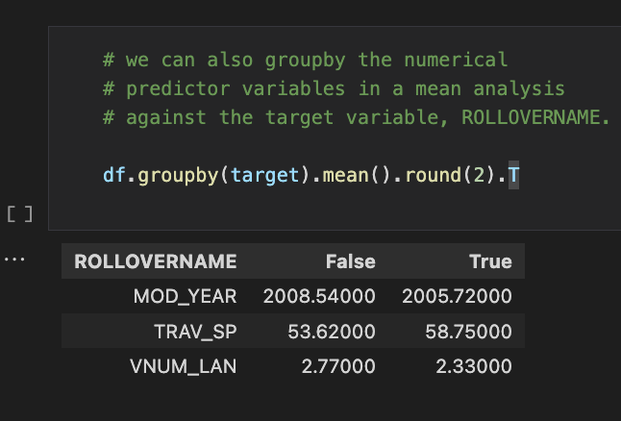

We then do an analysis of the numerical predictor variables against the target variable to see the mean values that are in each category. The mean values for ROLLOVERNAME_True are 2005.72 for the MOD_YEAR, 58.75 mph for the TRAV_SP, and 2.33 for the VNUM_LAN.

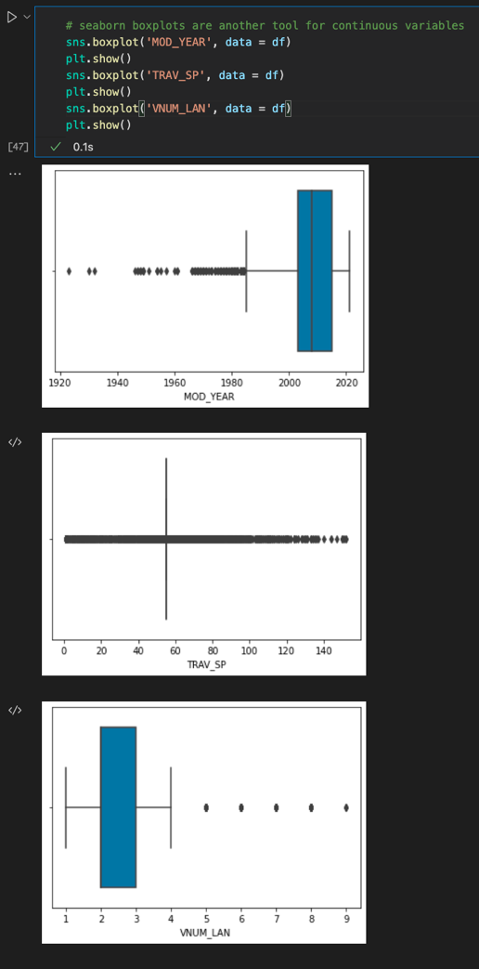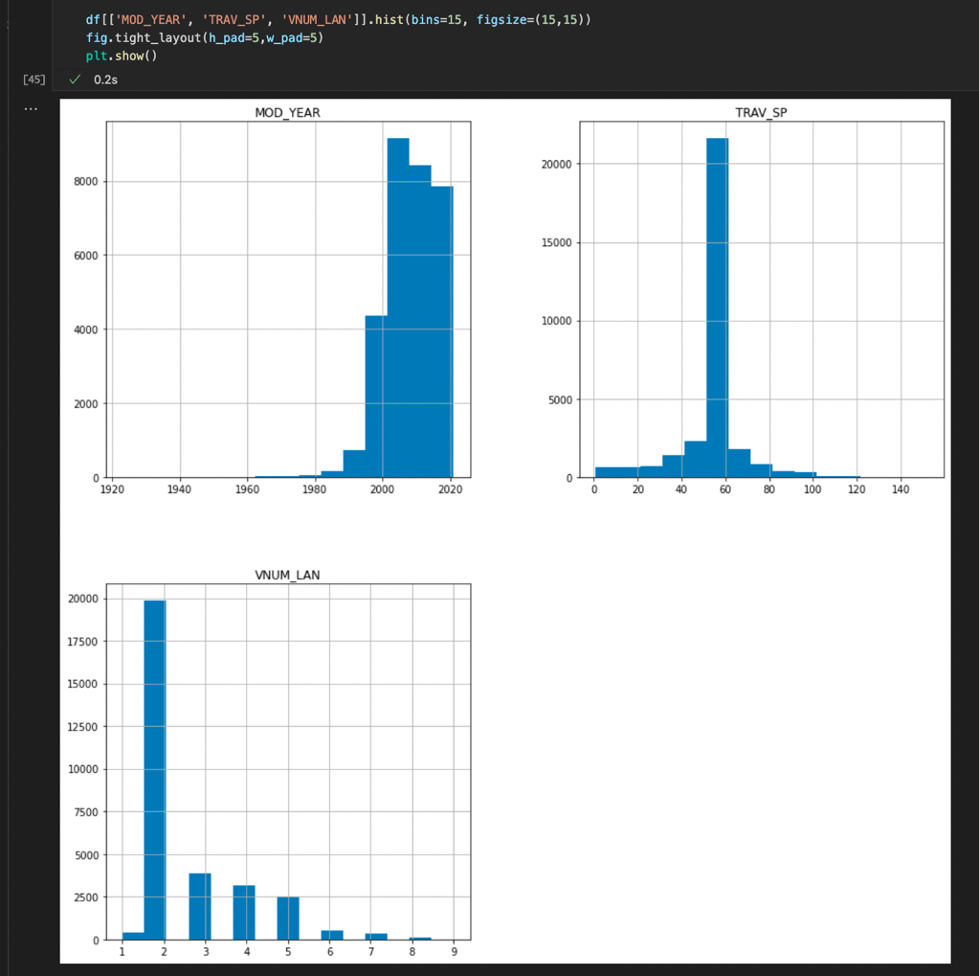We do another univariate analysis of the numerical predictor variables. Most of the accidents that took place at cars that were manufactured between 2000-2020, most were traveling about 55mph, and most were traveling on a 2-lane road.

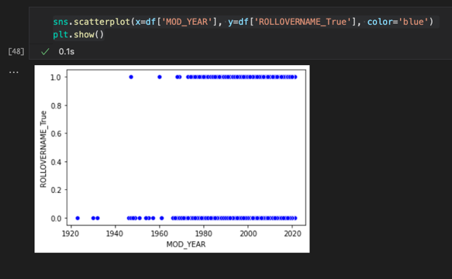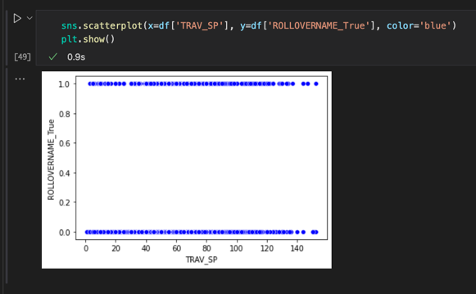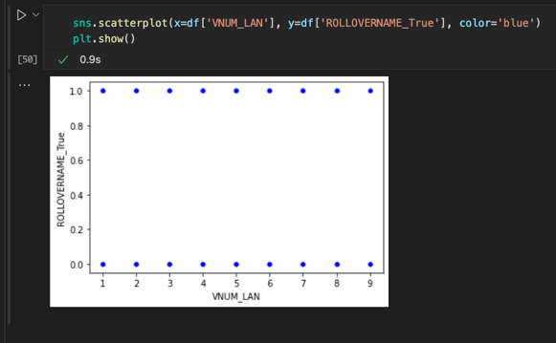

We have a seaborn plot and scatterplots for the numerical predictor variables, as well. These show the distribution of values across the dataset.

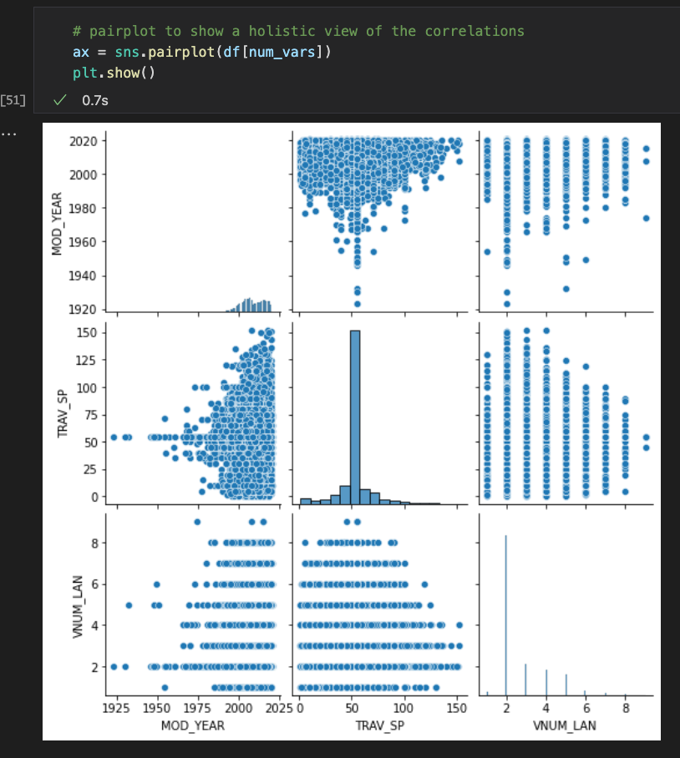Another graphical representation for a bivariate analysis is the sns.pairplot function. This depicts a correlation between all the numerical predictor variables.

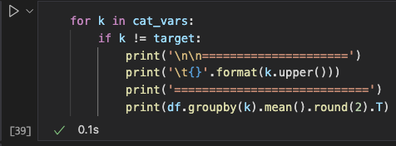

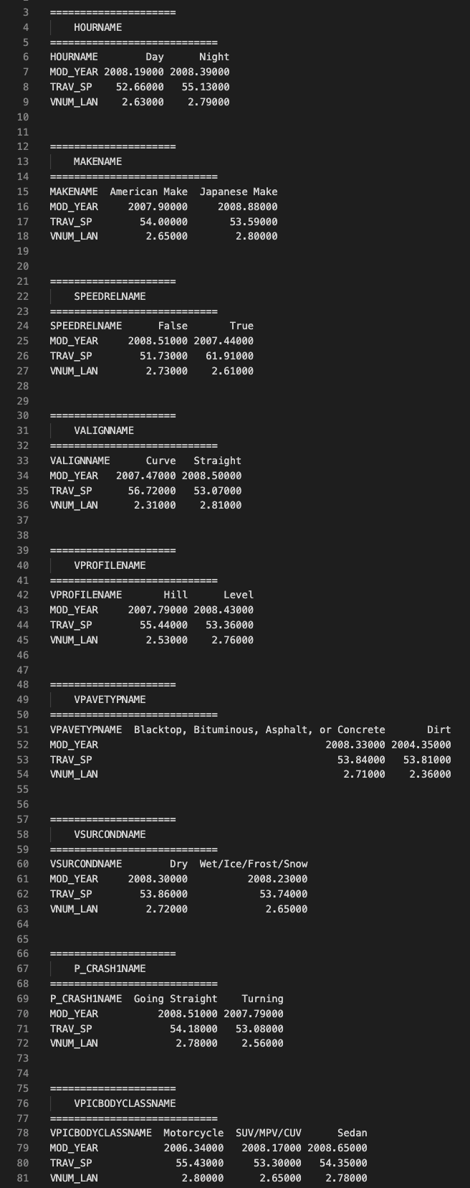

The next step is to do a univariate and bivariate analysis on the categorical predictor variables. The analysis below shows us the count of the categorical variables. The univariate countplot for the categorical variables. Next, we do a group by correlation of the categorical variables against the numerical variables. This is shown on the right.

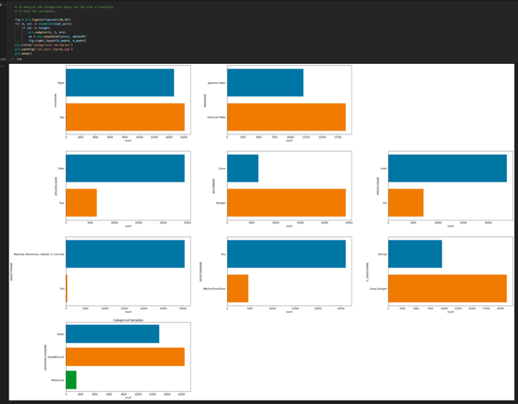

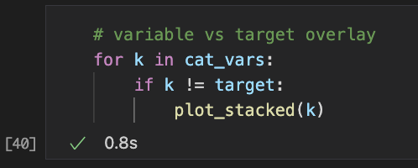Next, we can do the bivariate analysis of the categorical predictor variables against the target variable.

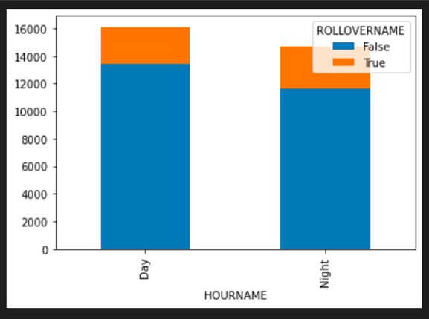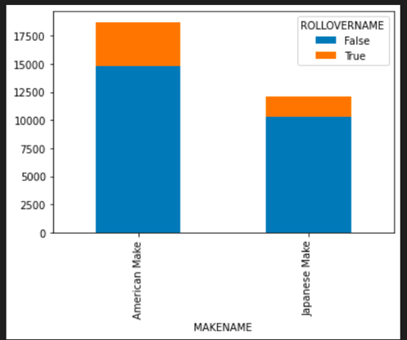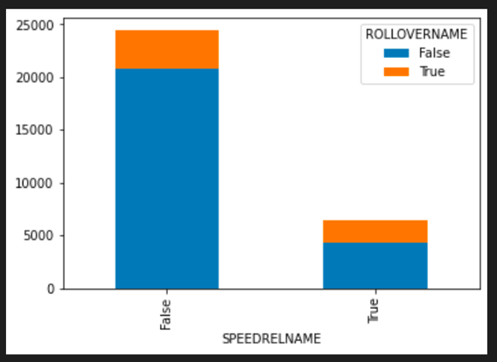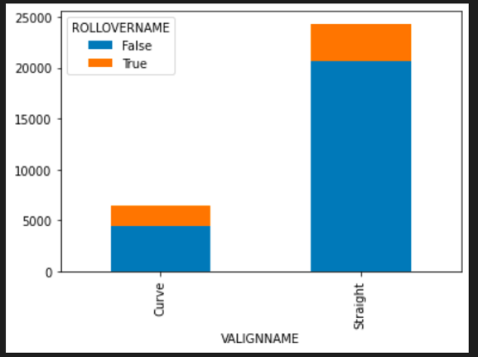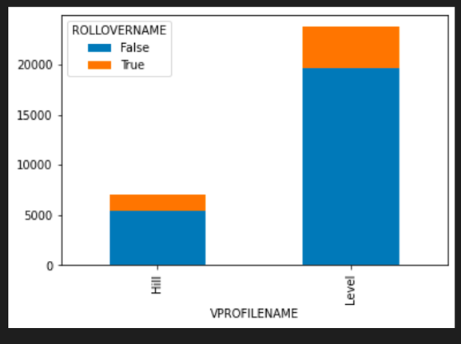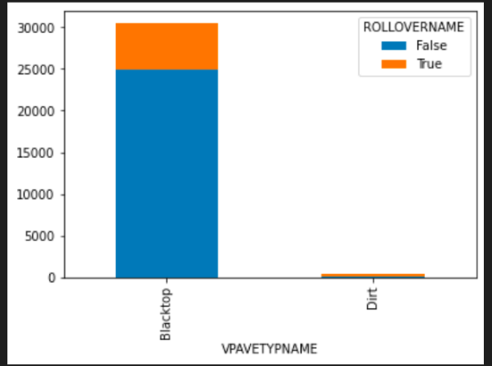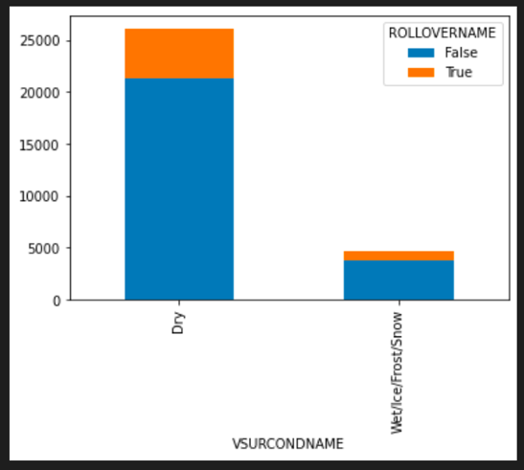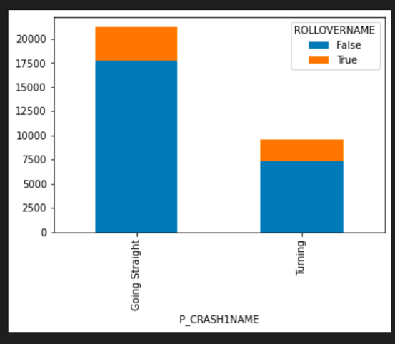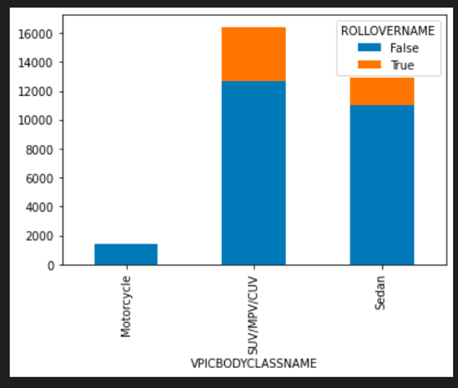

We then convert the categorical variables to dummy variables.

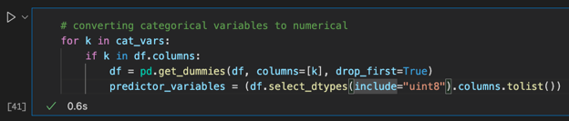

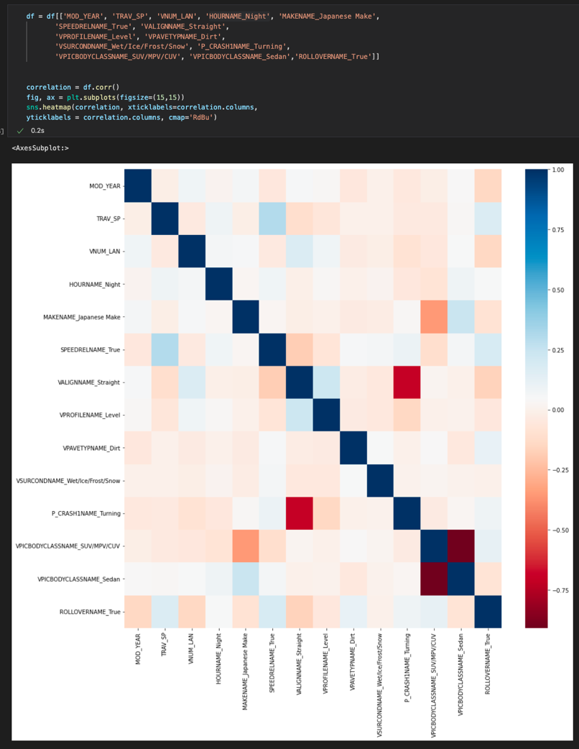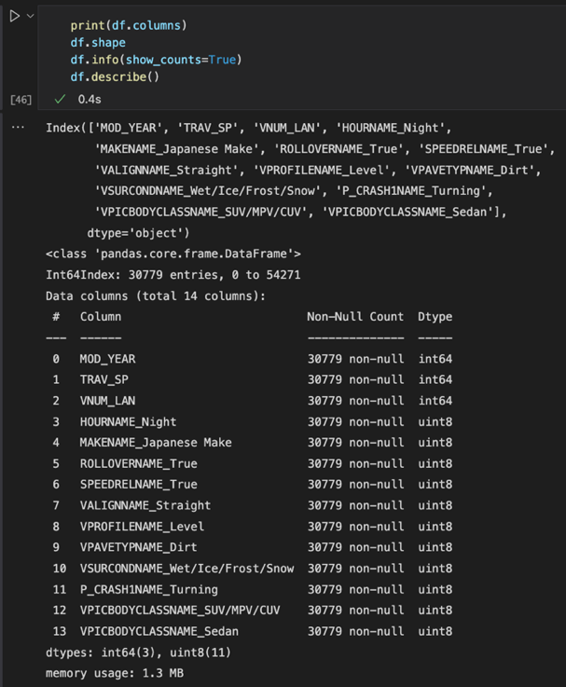Once we have the dummy variables, we can reorganize the dataframe to put ROLLOVERNAME_True at last. We can then create a heatmap.

We can see the correlation between all the dummy variables against ROLLOVERNAME_True. The redder it is, the higher correlation.

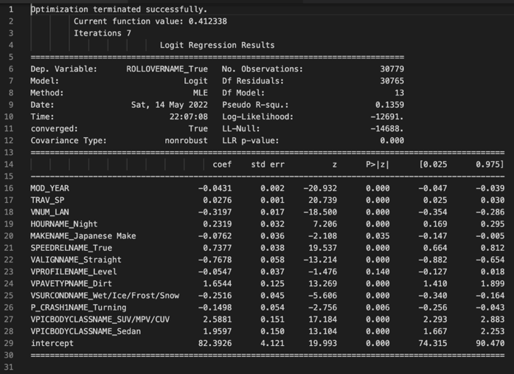Lastly, we’ll do a logistic regression analysis. The pseudo R2 value 13.59%. There are different opinions of what qualifies as a good R2 variance. Cohen (1988) designates moderate R2 value as 0.13 and above. Falk and Miller (1991) designated R2 values should be greater than or equal to 0.10 for the variance to be explained adequately. We will also do a correlation report to see the top absolute correlations between variables.

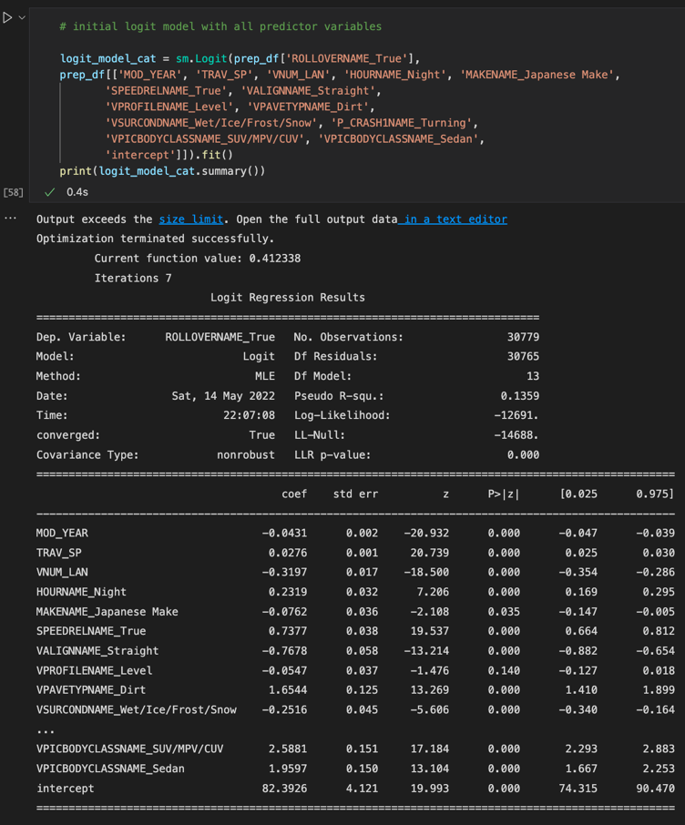

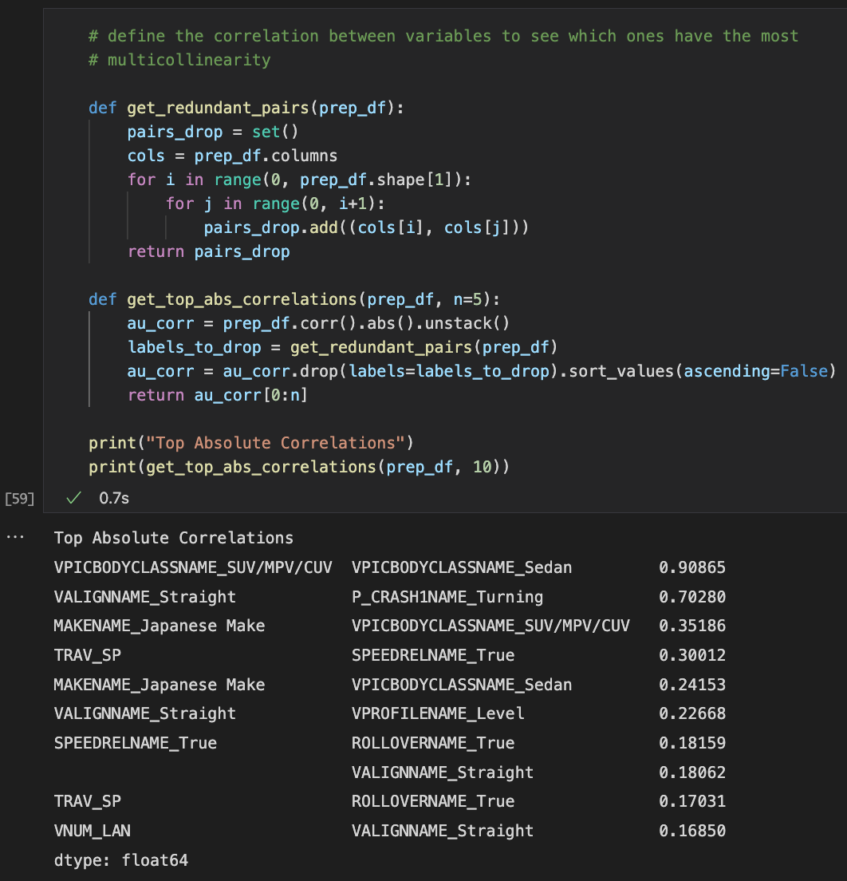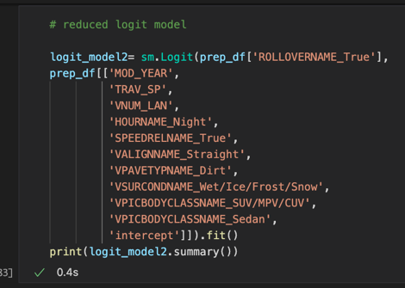The P-values for MAKENAME_Japanese Make and VPROFILENAME_Level are higher than the others. Our p-value will be 0.05 and any variables that have a higher p-value may not be statistically significant. We can look to remove these variables. We also notice a high correlation between a few of the variables. We can look to remove a few of the variables to reduce the multicollinearity.

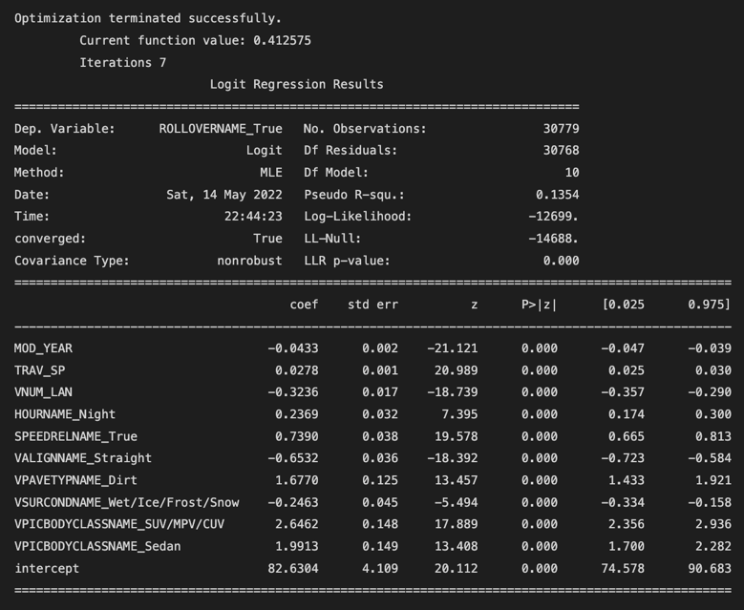

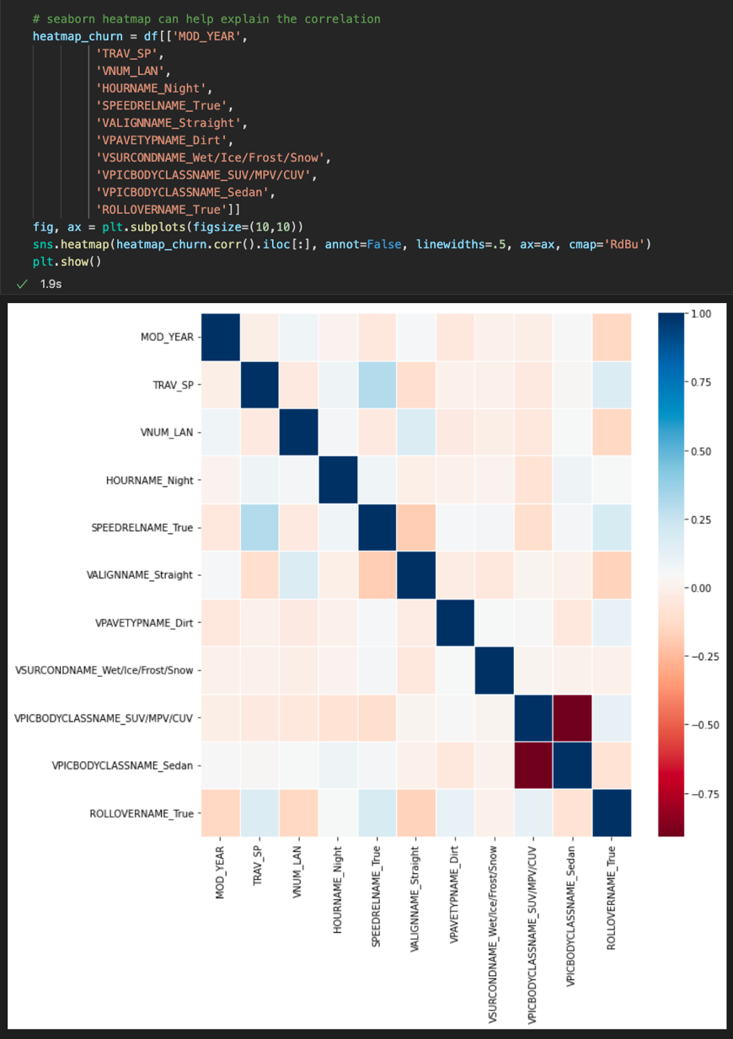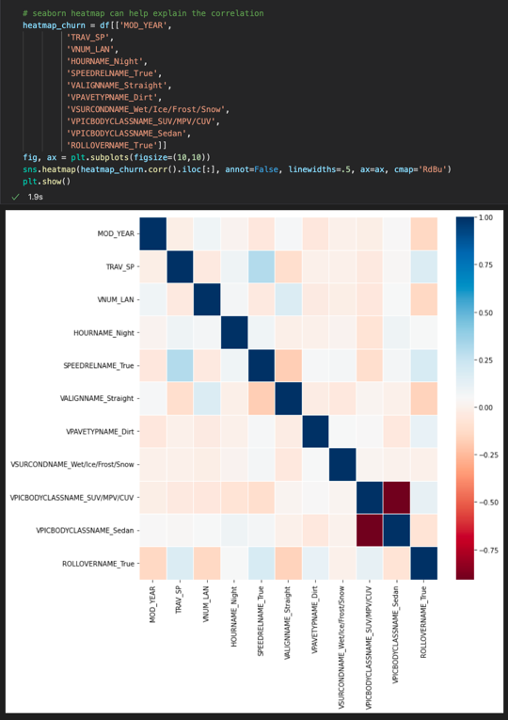We create a heatmap to help explain the correlation between the variables in the reduced logit model. There is still a high correlation between VBODYCLASSNAME_SUV/MPV/CUV and VBODYCLASSNAME_Sedan. I wanted to remove one of these variables but the R2 value decreased significantly to 0.12. I decided to keep them both in the equation. We can see a model evaluation metric through the heatmap and a confusion matrix.

The final reduced logistic model will include the following variables:

1. MOD_YEAR
2. TRAV_SP
3. VNUM_LAN
4. HOURNAME_Night
5. SPEEDRELNAME_True
6. VALIGNNAME_Straight
7. VPAVETYPNAME_Dirt
8. VSURCONDNAME_Wet/Ice/Frost/Snow
9. VPICBODYCLASSNAME_SUV/MPV/CUV
10. VPICBODYCLASSNAME_Sedan

This list includes 11 total variables, 3 of which are numerical and 7 of which are categorical. We started with 13 variables, and we end with 10 variables in the reduced model. The original logistical model had an R2 of 0.1359 and the reduced model had an R2 of 0.1354.

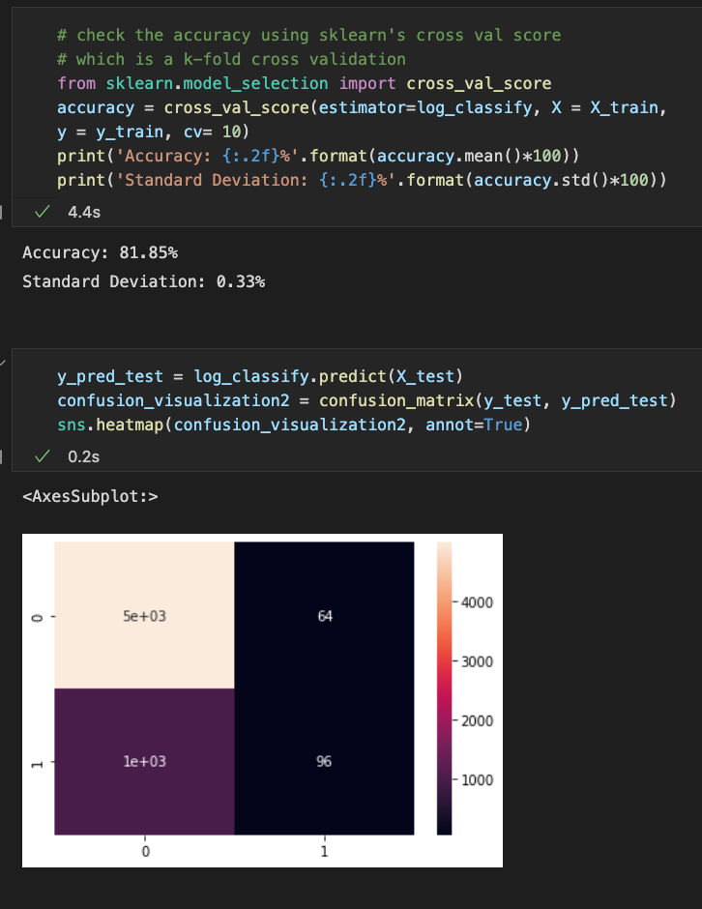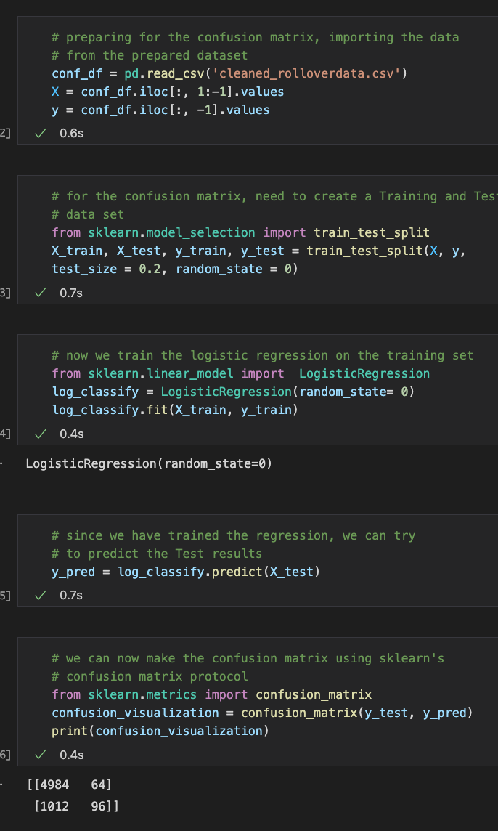Now we can create a confusion matrix using sklearn.

**Part E. Data Summary and Implications:** Summarize the implications of your data analysis by discussing the results of your data analysis in the context of the research question, including any limitations of your analysis. Within the context of your research question, recommend a course of action based on your results. Then propose two directions or approaches for future study of the data set.

The data analysis that was conducted was a logistic regression analysis of predictor variables that affect the target variable, ROLLOVER. The research question is which factors affected rollovers in accidents that occurred in 2020?

The logistic model had been regressed and was completed as far as being a proper fit. There is a variation of variables of 3 numerical and 7 categorical.

The regression equation for the final model is:

$$y=82.630 \left(const\right)-0.043 x \left(MOD_YEAR\right)+0.028x \left(TRAV_SP\right)-0.324 x \left(VNUM_LAN\right)+0.237 x \left(HOURNAME_Night\right)+0.739 x \left(SPEEDRELNAME_True\right)-0.653 x \left(VALIGNNAME_Straight\right)+1.677 x \left(VPAVETYPNAME_Dirt\right)-0.246 x \left(VSURCONDNAME_Wet/Ice/Frost/Snow\right)+2.646 x \left(VPICBODYCLASSNAME_SUV/MPV/CUV\right)+1.991 x \left(VPICBODYCLASSNAME_Sedan\right)$$

This model has a total of 10 predictor variables, the pseudo-R value is 0.1354 which means that 13.54% of the variance can be explained by this model. This indicates a decent model and fit for explaining variability according to Cohen (1988).

The equation shows us that the top variables that affect ROLLOVER are SPEEDRELNAME_True, VPAVETYPNAME_Dirt, VPICBODYCLASSNAME_SUV/MPV/CUV, and VPICBODYCLASSNAME_Sedan. That means that driving over the speed limit affected ROLLOVERs in accidents. Also, VPAVETYPNAME_Dirt has a coefficient of +1.677 which means that this dirt on the road positively affects ROLLOVERs in accidents. Lastly, VPICBODYCLASS_SUV/MPV/CUV and VPICBODYCLASS_Sedan have positive coefficients that affect a ROLLOVER. Drivers in an SUV, MPV, or CUV are generally 2.646 times more likely to get into a rollover accident. Another variable that affects rollover is VALIGNNAME_Straight which has a coefficient of -0.653. That means that drivers are less likely to get into a rollover accident when driving on a straight road.

The equation may be able to accurately predict the affect of variables on ROLLOVER depending on the type of vehicle (SUV/MPV/CUV vs Sedan), the pavement type (dirt), and the exceeding speed limits.

Limitations of the data analysis would be that there are an extensive number of rows that have Unknown or Not Reported values. Therefore, we had to change some of the values to the median value of the variable.

The recommended course of action is to educate drivers at the point of purchasing a vehicle that an SUV/MPV/CUV has a more likely chance of rolling over during an accident in comparison to Sedan vehicles. Another point of emphasis is to have signs in areas where there are dirt roads to tell people the dangers of exceeding the speed limit; one of the dangers include rolling over during accident. Also, during DMV license examination, it would benefit drivers to know that one of the dangers of driving in excess of the speed limit on curvy roads can lead to rollover accidents.

Two approaches for future study of this dataset would include which factors affect fatal accidents and which kind of accidents motorcycles engaged in most. This would be to educate drivers and motorists in order to reduce fatalities and motorcycle accidents. A further study could also dive deeper into the correlations between these variables.

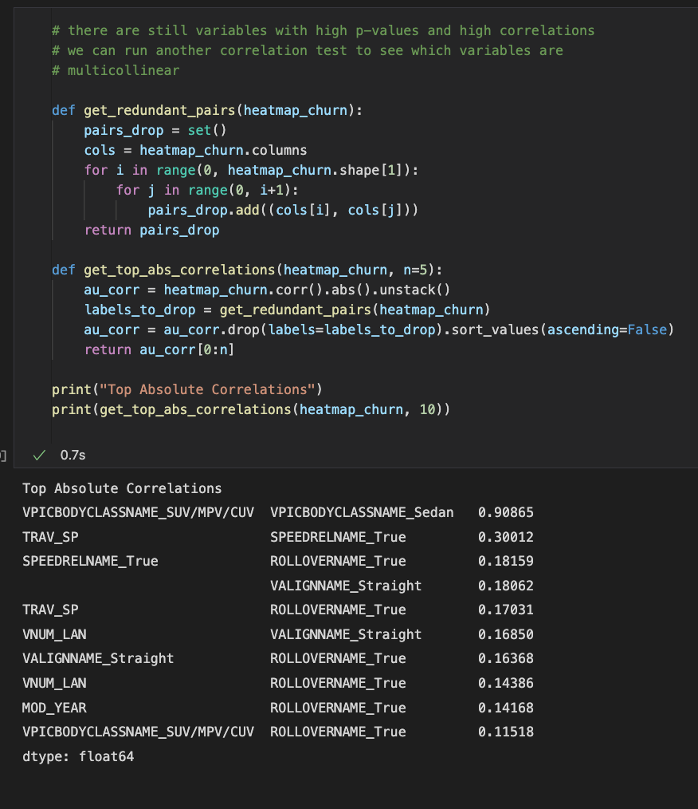

F. Acknowledge sources, using in-text citations and references, for content that is quoted paraphrased, or summarized.

Cohen, J. 1988. Statistical Power Analysis for the Behavioral Sciences, 2nd Ed. New York: Routledge.